## VIVEKANAND EDUCATION SOCIETY’S INSTITUTE OF TECHNOLOGY

**Department of Computer Engineering**



Project Report on

Crucial Need-Real time prenatal health monitoring

In partial fulfilment of the Fourth Year, Bachelor of Engineering (B.E.) Degree in Computer Engineering at the University of Mumbai

Academic Year 2024-25

### Submitted by

Prerna Banswani - D17C - 05

Kalpana Gurnani - D17C- 21

Madhura Gaval - D17B - 13

Vanshika Lalwani - D17B- 26

### Project Mentor

Prof. Nusrat Ansari

(2024-25)

## VIVEKANAND EDUCATION SOCIETY’S INSTITUTE OF TECHNOLOGY

**Department of Computer Engineering**



**Certificate**

This is to certify that **Prerna Banswani(D17C, 05), Kalpana Gurnani (D17C, 21), Madhura Gaval (D17B, 13), Vanshika Lalwani (D17B, 26*)*** of Fourth Year Computer Engineering studying under the University of Mumbai have satisfactorily completed the project on “**Crucial Need-Real time prenatal health monitoring** ” as a part of their coursework of PROJECT-II for Semester-VIII under the guidance of their mentor **Prof. Nusrat Ansari** in the year 2024-25 .

This project report entitled **Crucial Need-Real time prenatal health monitoring** by ***Prerna Banswani, Kalpana Gurnani, Madhura Gaval, Vanshika Lalwani*** is approved for the degree of **B.E. Computer Engineering.**

| Programme Outcomes | Grade |
| --- | --- |
| PO1,PO2,PO3,PO4,PO5,PO6,PO7, PO8, PO9, PO10, PO11, PO12 PSO1, PSO2 |  |

Date:

Project Guide:



**Project Report Approval**

**For B. E (Computer Engineering)**

This project report entitled **Crucial Need-Real time prenatal health monitoring** by ***Prerna Banswani, Kalpana Gurnani, Madhura Gaval, Vanshika Lalwani*** is approved for the degree of **B.E. Computer Engineering.**

Internal Examiner



External Examiner



Head of the Department



Principal



Date:

Place: Mumbai

**Declaration**

We declare that this written submission represents our ideas in our own words and where others' ideas or words have been included, we have adequately cited and referenced the original sources. We also declare that we have adhered to all principles of academic honesty and integrity and have not misrepresented or fabricated or falsified any idea/data/fact/source in our submission. We understand that any violation of the above will be cause for disciplinary action by the Institute and can also evoke penal action from the sources which have thus not been properly cited or from whom proper permission has not been taken when needed.



Prerna Banswani(D17C-05) Madhura Gaval(D17B-13)



Kalpana Gurnani(D17C-21) Vanshika Lalwani(D17B-26)

Date:

# ACKNOWLEDGEMENT

We are thankful to our college Vivekanand Education Society’s Institute of Technology for considering our project and extending help at all stages needed during our work of collecting information regarding the project.

It gives us immense pleasure to express our deep and sincere gratitude to Assistant Professor **Prof. Nusrat Ansari** (Project Guide) for her kind help and valuable advice during the development of project synopsis and for her guidance and suggestions.

We are deeply indebted to Head of the Computer Department **Dr. (Mrs.) Nupur Giri** and our Principal **Dr. (Mrs.) J. M. Nair ,** for giving us this valuable opportunity to do this project.

We express our hearty thanks to them for their assistance without which it would have been difficult in finishing this project synopsis and project review successfully.

We convey our deep sense of gratitude to all teaching and non-teaching staff for their constant encouragement, support and selfless help throughout the project work. It is a great pleasure to acknowledge the help and suggestion, which we received from the Department of Computer Engineering.

We wish to express our profound thanks to all those who helped us in gathering information about the project. Our families too have provided moral support and encouragement several times.

### Computer Engineering Department COURSE OUTCOMES FOR B.E PROJECT

Learners will be to,

| **Course Outcome** | **Description of the Course Outcome** |
| --- | --- |
| CO 1 | Able to apply the relevant engineering concepts, knowledge and skills towards the project. |
| CO2 | Able to identify, formulate and interpret the various relevant research papers and to determine the problem. |
| CO 3 | Able to apply the engineering concepts towards designing solutions for the problem. |
| CO 4 | Able to interpret the data and datasets to be utilised. |
| CO 5 | Able to create, select and apply appropriate technologies, techniques, resources and tools for the project. |
| CO 6 | Able to apply ethical, professional policies and principles towards societal, environmental, safety and cultural benefit. |
| CO 7 | Able to function effectively as an individual, and as a member of a team, allocating roles with clear lines of responsibility and accountability. |
| CO 8 | Able to write effective reports, design documents and make effective presentations. |
| CO 9 | Able to apply engineering and management principles to the project as a team member. |
| CO 10 | Able to apply the project domain knowledge to sharpen one’s competency. |
| CO 11 | Able to develop a professional, presentational, balanced and structured approach towards project development. |
| CO 12 | Able to adopt skills, languages, environment and platforms for creating innovative solutions for the project. |

# Index

| Chapter No. | Title | Page No. |
| --- | --- | --- |
| **1** | **Introduction** | 11 |
| 1.1 | Introduction to the project | 11 |
| 1.2 | Motivation for the project | 11 |
| 1.3 | Problem Definition | 12 |
| 1.4 | Existing Systems | 13 |
| 1.5 | Lacuna of the Existing Systems | 13 |
| 1.6 | Relevance of the Project | 13 |
| **2** | **Literature Survey** | 14 |
| A | Brief overview of Literature Survey | 14 |
| 2.1 | Research Papers   1. Abstract of the research paper 2. Inference drawn from the paper | 14 |
| 2.2 | Patent search   1. Title of the patent and year of the patent 2. Summary of the patent 3. Link 1. European Patent: [http://worldwide.espacenet.com/,](http://worldwide.espacenet.com/) Link 2. Google Patents: https://patents.google.com/ | 19 |
| 2.3 | Inference Drawn | 20 |
| 2.4 | Comparison with the Existing Systems | 21 |
| **3.** | **Requirement Gathering for the proposed System** | 22 |
| 3.1 | Introduction to Requirement Gathering | 22 |
| 3.2 | Functional Requirements | 23 |
| 3.3 | Non-Functional Requirements | 23 |
| 3.4 | Hardware, Software, Technology and tools utilised | 23 |
| 3.5 | Constraints | 25 |
| **4.** | **Proposed Design** | 26 |
| 4.1 | Block diagram of the system | 26 |
| 4.2 | Architecture design of the system | 27 |

| 4.3 | Detailed Design (Flowchart) | 28 |
| --- | --- | --- |
| 4.4 | Project Scheduling &amp; Tracking using Timeline / Gantt Chart | 30 |
| **5.** | **Implementation of the Proposed System** | 31 |
| 5.1 | Methodology employed for development | 31 |
| 5.2 | Algorithms and flowcharts for the respective modules developed | 32 |
| 5.3 | Datasets source and utilisation | 33 |
| **6.** | **Testing of the Proposed System** | 34 |
| 6.1 | Introduction to testing | 34 |
| 6.2 | Types of tests Considered | 34 |
| 6.3 | Various test case scenarios considered | 35 |
| 6.4 | Inference drawn from the test cases | 36 |
| **7.** | **Results and Discussions** | 39 |
| 7.1 | Screenshots of User Interface (UI) for the respective module | 38 |
| 7.2 | Performance Evaluation measures | 42 |
| 7.3 | Input Parameters / Features considered | 43 |
| 7.4 | Comparison of results with existing systems | 45 |
| 7.5 | Inference drawn | 45 |
| **8.** | **Conclusion** | 46 |
| 8.1 | Limitations | 46 |
| 8.2 | Conclusion | 46 |
| 8.3 | Future Scope | 46 |
|  | **References** | 47 |
|  | **Appendix** | 49 |
| **1** | **Paper I** | 49 |
| a | Paper I | 49 |
| b | Plagiarism Report of Paper I | 65 |
| c | Project review sheet | 65 |

**List of Figures:**

| Fig no. | Heading | Page no. |
| --- | --- | --- |
| 4.1 | Block Diagram | 27 |
| 4.2 | Architecture Diagram | 28 |
| 4.3 | System Flowchart | 29 |
| 4.4 | Connection details and Pin Diagram | 30 |
| 4.5 | Gantt Chart | 31 |
| 7.1 | Real-Time Fetal Heart Rate Monitoring Visualization | 40 |
| 7.2 | Real-Time Fetal Heart Rate Monitoring Visualization :X-axis | 40 |
| 7.3 | Real-Time Fetal Heart Rate Monitoring Visualization:Y-axis | 41 |
| 7.4 | Real-Time Fetal Heart Rate Monitoring Visualization:Z-axis | 41 |
| 7.5 | Mother’s Dashboard | 41 |
| 7.6 | Doctor’s Dashboard | 42 |
| 7.7 | Real-Time Visualization | 42 |
| 7.8 | Readings from Sensors | 42 |
| 7.9 | Chat Support | 43 |
| 7.10 | Appointments Scheduled | 43 |
| 7.11 | Input from sensors :A | 45 |
| 7.12 | Input from sensors: B | 45 |
| 7.13 | Input from sensors: C | 45 |

**List of Tables:**

| Table no. | Heading | Page no. |
| --- | --- | --- |
| 2.1 | Comparison with Existing System | 23 |
| 3.1 | Requirements of the system | 21 |

# Abstract

Ensuring the continuous monitoring of fetal heart health is paramount to safeguarding both maternal and fetal well-being. Traditional clinic-based assessments, which are typically conducted at scheduled intervals, may not always capture transient irregularities or early warning signs of potential complications. This limitation can lead to delayed diagnoses and interventions, increasing the risk of adverse pregnancy outcomes. To address this critical gap, we propose the development of an advanced, non-invasive wearable device designed to enable real-time fetal heart rate monitoring.

The proposed system integrates cutting-edge sensor technology to provide continuous and accurate tracking of fetal heart activity. Unlike conventional fetal monitoring methods that rely on intermittent check-ups, our wearable device is designed for continuous operation, ensuring seamless data collection throughout the day and night. It is lightweight, comfortable, and easy to use, making it suitable for daily wear by expectant mothers without causing discomfort or inconvenience.

A key innovation of our system is its AI-powered analytical framework, which processes the acquired fetal heart rate data to detect subtle anomalies or irregularities that may indicate potential health concerns. The system employs machine learning algorithms to analyze trends, compare historical data, and identify deviations from normal fetal heart rate patterns. Upon detecting an anomaly, the device generates real-time alerts, enabling timely medical attention and intervention.

To enhance accessibility and usability, the device is equipped with wireless connectivity, allowing seamless data transmission to a mobile application. Through this application, users can access real-time monitoring insights, receive automated alerts, and view historical trends of fetal heart health. Additionally, healthcare professionals can leverage the collected data for remote monitoring, thereby facilitating proactive prenatal care and informed medical decision-making.

By providing a continuous, intelligent, and user-friendly fetal monitoring solution, this innovation empowers expectant mothers with valuable health insights while supporting medical professionals in identifying potential complications at an early stage. The system has the potential to revolutionize prenatal care by bridging the gap between intermittent clinical check-ups and real-time fetal health monitoring. Ultimately, this technology aims to enhance pregnancy outcomes, reduce risks associated with fetal distress, and improve overall maternal-fetal health through early detection and timely intervention.

# Chapter 1: Introduction

## Introduction:

Monitoring fetal heart health is a crucial aspect of prenatal care, as it provides essential insights into the baby’s well-being. Conventional monitoring techniques, such as Doppler ultrasound [5,15,16] and electronic fetal monitoring, are typically performed during scheduled medical check-ups. While effective, these approaches only offer intermittent data, making it possible for temporary irregularities to go unnoticed. This limitation can delay medical responses and increase the risk of pregnancy complications.

High-risk pregnancies, in particular, require more frequent and detailed monitoring to detect potential health concerns early. However, the need for multiple clinical visits can be inconvenient for expectant mothers and place additional demands on healthcare systems. A continuous and real-time fetal monitoring solution could bridge this gap by offering uninterrupted tracking, reducing dependence on hospital-based evaluations, and providing immediate alerts in case of abnormalities.

This research focuses on developing a wearable device equipped with advanced sensors to monitor fetal heart rate continuously. The proposed system is designed to collect and analyze real-time health data, detect anomalies, and transmit information to a mobile application for instant access. By enabling remote monitoring and early detection of potential concerns, this solution aims to enhance maternal healthcare, improve pregnancy outcomes, and provide reassurance to expectant mothers.

## Motivation:

The health and well-being of both the mother and the fetus are of paramount importance during pregnancy. One of the critical aspects of prenatal care is the continuous monitoring of fetal heart rate, which serves as a key indicator of fetal health. However, traditional fetal monitoring methods rely on periodic clinical assessments, often conducted during scheduled prenatal visits. While these assessments provide valuable insights, they are intermittent and may fail to detect short-term variations or sudden abnormalities in fetal heart activity. This limitation can lead to delayed diagnosis of potential complications, increasing the risk of adverse pregnancy outcomes.

Several fetal health conditions, such as fetal distress, arrhythmias, and intrauterine growth restriction (IUGR), can manifest through subtle but significant changes in heart rate patterns. Early detection of such abnormalities is crucial for timely medical intervention, potentially preventing complications such as premature birth, stillbirth, or neonatal distress. The need for a reliable, non-invasive, and continuous fetal heart monitoring system has therefore become more pressing than ever.

Advancements in wearable technology, artificial intelligence, and the Internet of Things (IoT) present an opportunity to bridge the gap between clinical monitoring and real-time, at-home fetal health tracking. A wearable device that continuously tracks fetal heart rate and provides instant insights could empower expectant mothers with real-time information about their baby’s well-being. Additionally, AI-driven analysis can detect subtle irregularities, allowing healthcare providers to make proactive decisions before complications arise.

This project is motivated by the vision of improving prenatal healthcare by integrating modern technology into fetal monitoring. By leveraging sensors, and wireless connectivity, we aim to develop a system that ensures continuous and intelligent fetal heart monitoring. This innovation will provide mothers with peace of mind, reduce the burden on healthcare systems, and ultimately contribute to better maternal and fetal health outcomes. Our goal is to make prenatal monitoring more accessible, efficient, and effective, ensuring that no warning signs go unnoticed and that every pregnancy receives the best possible care.

## Problem Definition:

Traditional fetal heart rate (FHR) monitoring techniques, such as Doppler ultrasound and cardiotocography, are inherently intermittent and reliant on scheduled clinical assessments. This periodic approach introduces critical gaps in fetal health surveillance, particularly in high-risk pregnancies, where continuous monitoring is imperative for early detection and timely intervention. The necessity of frequent hospital visits not only imposes logistical and financial burdens on expectant mothers but also strains healthcare infrastructure, thereby limiting the accessibility of essential prenatal care—especially in remote or resource-constrained regions.

Furthermore, the episodic nature of conventional monitoring methods may result in delayed identification of transient fetal distress episodes, potentially leading to adverse pregnancy outcomes. The absence of real-time, continuous tracking deprives both healthcare providers and expectant mothers of immediate insights into fetal well-being, thereby diminishing opportunities for proactive medical decision-making.

To address these limitations, there is a pressing need for an advanced, non-invasive fetal heart rate monitoring system that seamlessly integrates wearable technology with artificial intelligence. Such a system would enable real-time data acquisition, continuous analysis of fetal heart activity, and automated anomaly detection, thereby facilitating early warning mechanisms and data-driven clinical interventions. By enhancing accessibility, minimizing dependence on clinical visits, and providing intelligent fetal health analytics, this innovation holds the potential to revolutionize prenatal care, ensuring improved maternal-fetal health outcomes and mitigating risks associated with undetected fetal distress

## Existing Systems:

Existing systems for maternal and fetal health monitoring primarily rely on periodic clinical assessments, which may fail to detect transient anomalies. Traditional hospital-based Doppler ultrasound monitoring provides fetal heart rate data, but it is not continuous and requires hospital visits. Consumer-grade wearable devices exist for heart rate tracking, but they often lack integration with AI for predictive insights and do not support real-time cloud-based monitoring.

Some IoT-based healthcare solutions provide remote monitoring, but they focus on general patient health rather than specialized maternal and fetal care. Mobile health apps can track symptoms, but they rely on manual input rather than sensor-driven real-time data collection. Thus, an integrated solution combining IoT, and real-time cloud connectivity is needed to bridge these gaps and provide a more effective approach to prenatal health monitoring.

## Lacuna of the Existing System:

* + 1. Intermittent clinic-based assessments can miss transient abnormalities.
    2. Delayed interventions increase pregnancy risks.
    3. Intermittent monitoring might delay the detection of potential issues, reducing the window for effective intervention.
    4. In rural or underserved areas, access to consistent prenatal monitoring is limited, leading to disparities in maternal and fetal health outcomes.
    5. Traditional monitoring methods do not provide the advanced detection capabilities necessary to identify subtle patterns and anomalies in fetal heart rate, which could indicate potential complications early on.

## Relevance of the Project:

The project is relevant as it provides a continuous, real-time, and non-invasive fetal heart rate monitoring solution using wearable sensor technology. Unlike traditional methods that require periodic clinical visits, this system allows expectant mothers to track their fetal and maternal heart rates anytime through an application. It enhances accessibility to prenatal care, reduces dependency on hospital visits, and ensures that users can monitor their readings conveniently, leading to better maternal and fetal health management.

# Chapter 2: Literature Survey

## A. Overview of literature survey:

The papers discussed here focus on various fetal heart rate monitoring techniques and their effectiveness in ensuring maternal and fetal well-being. These studies analyze different monitoring systems, including Doppler ultrasound, cardiotocography (CTG), and wearable sensor-based solutions, to understand their advantages and limitations. The research examines how continuous monitoring can improve early detection of fetal distress and enhance prenatal care. Overall, the papers highlight the importance of developing a comprehensive system that enables real-time fetal and maternal heart rate tracking, ensuring better accessibility and more effective health management for expectant mothers.

## Research Papers :

* + 1. **M. Roham, E. Saldivar, S. Raghavan, M. Zurcher, J. Mack and M. Mehregany, "A mobile wearable wireless fetal heart monitoring system," 2011 5th International Symposium on Medical Information and Communication Technology, Montreux, Switzerland, 2011, pp. 135-138,** [**doi: 10.1109/ISMICT.2011.5759813.**](https://ieeexplore.ieee.org/document/5759813)
       1. **Abstract:** A wireless and mobile system for concurrent non-invasive monitoring of fetal heart rate and uterine contractions is described. The end-to-end system consists of a wearable Doppler ultrasound and pressure sensing front-end equipped with short range radio, mobile cellular gateway for wide area communication, web server, and browser based user interface for remote monitoring and diagnostics. The system has been fully implemented, tested and characterized in benchtop tests. It has also been used to monitor pregnant women during feasibility trials in a clinical setup. In vivo experiments measuring heart rate and contraction using the system in parallel with a standard fetal monitoring device yielded concordance correlation coefficients of 88% and 94%, respectively.
       2. **Inference:** This study presents a wireless and mobile system designed for non-invasive monitoring of fetal heart rate and uterine contractions, integrating Doppler ultrasound and pressure sensors. The system enables real-time data transmission via short-range radio and a mobile cellular gateway, allowing remote monitoring through a web-based interface. The implementation has been successfully tested through benchtop experiments and feasibility trials with pregnant women in a clinical setting. The high concordance correlation coefficients (88% for heart rate and 94% for contractions) indicate strong agreement with standard fetal monitoring devices, demonstrating the system's reliability and potential for enhancing prenatal care through continuous, remote monitoring.
    2. **Runkle J, Sugg M, Boase D, Galvin SL, C Coulson C. Use of wearable sensors for pregnancy health and environmental monitoring: Descriptive findings from the perspective of patients and providers. Digit Health. 2019 Feb 6;5:2055207619828220.** [**doi: 10.1177/2055207619828220**](http://pubmed.ncbi.nlm.nih.gov/30792878/)**. PMID: 30792878; PMCID: PMC6376550.**
       1. **Abstract:** Wearable sensors and smart technology have the potential to enhance prenatal care by enabling remote health monitoring, yet little research has examined patient and provider perceptions regarding their implementation. This study explores the acceptance and preferences of pregnant women and healthcare providers in a rural health clinic regarding the use of wearable sensors to monitor health and environmental exposures during pregnancy. Surveys were conducted among 103 pregnant women and 28 healthcare providers, revealing that patients are willing to use wearable sensors, have minimal privacy concerns, and are open to behavioral changes based on personalized recommendations. While most providers do not currently use wearable technology in practice, many believe it will play a greater role in the future for diagnosis and remote monitoring. Patients prioritized fetal heart rate and blood pressure monitoring, whereas providers emphasized blood pressure and blood glucose tracking. The study concludes that both groups see value in wearable sensor technology, but further research is needed to understand provider adoption barriers and optimize its integration into prenatal healthcare.
       2. **Inference:** This study highlights the positive perception of both pregnant women and healthcare providers toward incorporating wearable sensor technology for prenatal health monitoring. The findings indicate that patients are open to using mobile sensors during pregnancy, have minimal privacy concerns, and are willing to share data with their physicians. Additionally, a significant number of women expressed a willingness to modify their behavior based on personalized recommendations received via smartphone technology. While providers do not currently rely heavily on smart technologies, many acknowledge their potential future role in remote patient monitoring. Patients showed a strong preference for tracking fetal heart rate and blood pressure, whereas providers prioritized blood pressure and blood glucose monitoring.
    3. [**Khizra saleem and Ashfaq, F. 2024. Smart Health Monitoring System for Pregnant Women of Rural Regions. Journal of Computers and Intelligent Systems. 1, 1 (May 2024).**](https://journals.iub.edu.pk/index.php/JCIS/article/view/2647)
       1. **Abstract:** Enhancements in healthcare capabilities improve living standards in the current era. Human capital is vital in technologically advanced and developing countries. In developing countries, maternal deaths occur due to a lack of medical facilities and infrastructure. The death ratio in pregnant women due to lack of medical facilities in advance and developing countries is 9:1. Most developing countries have poor medical information systems, which causes pregnant women to have very few routine check-ups in the early stages of their confinement. This results in an increased death rate of infants and maternal in backward regions. This is nowadays a major health concern for pregnant women of rural regions in developing countries. Existing medical approaches for such issues consist of

devices and wired sensors which are very costly. Ultrasound examinations are performed using Bluetooth devices as well. But these approaches are costly and not easily available in backward regions. The proposed framework helps to solve this issue using wireless technology. The physical movement of a fetus as well as maternal are measured using commercial-off-the-shelf sensors. These sensors consist of an accelerometer, temperature sensor, heart rate sensor, and blood pressure. Sensor data is forwarded using IoT to the mobile phone. Mobile phones transmit the collected data to the cloud for processing, analysis and results, and storage.

* + - 1. **Inference:**This document introduces the development of JobFit, a job recommendation engine that uses a recommendation engine, machine learning techniques, and historical data to predict the most suitable candidate for a job. The proposed job recommendation system takes as input a job requisition and the applicant profile and generates a JobFit score that indicates how fit each applicant is for the job. Ultimately, the system provides HR professionals with a ranking of all candidates and first recommends those who are the most suitable and fit for the job. This ensures that HR focuses on selecting and interviewing only a small group of candidates best recommended by the system, while knowing the best candidates won't be lost.
    1. **X. Zhao,X. Zeng,L. Koehl,G. Tartare,J. De Jonckheere Susana Bernardino and J. Freitas Santos. “A wearable system for in-home and long-term assessment of fetal movement**

[**https://doi.org/10.1016/j.irbm.2019.11.003**](https://www.sciencedirect.com/science/article/abs/pii/S1959031819301150?via%3Dihub)

* + - 1. **Abstract:** Significant health care resources are allocated to monitoring high risk pregnancies to minimize growth compromise, reduce morbidity and prevent stillbirth. Fetal movement has been recognized as an important indicator of fetal health. Studies have shown that 25% of pregnancies with decreased fetal movement in the third trimester led to poor outcomes at birth. The studies have also shown that maternal perception of fetal movement is highly subjective and varies from person to person. A non-invasive system for fetal movement detection that can be used outside hospital would represent an advance in at-home monitoring of at-risk pregnancies. This is a challenging task that requires the use of advanced signal processing techniques to differentiate genuine fetal movements from contaminating artefacts.
      2. **Inference:** This manuscript proposes a novel algorithm for automatic fetal movement recognition using data collected from wearable tri-axial accelerometers strategically placed on the maternal abdomen. The novelty of the work resides in the efficient removal of artefacts and in distinctive feature extraction. The proposed algorithm used independent component analysis (ICA) for dimensionality reduction and artefact removal. A supplemental technique based on discrete wavelet transform (DWT) was also used to remove artefacts.
    1. **Marin, N. Goga, A. Vasilateanu, A. Gradinaru and V. Racovita, "Smart Solution for the Detection of Preeclampsia," 2019 E-Health and Bioengineering Conference (EHB), Iasi, Romania, 2019, pp. 1-4,** [**doi: 10.1109/EHB47216.2019.8969948.**](https://ieeexplore.ieee.org/abstract/document/8969948)
       1. **Abstract:** This paper is written in the context of the international Eurostars project, i-bracelet. The main objective of the i-bracelet project - "Intelligent bracelet for blood pressure monitoring and detection of preeclampsia" is the creation of a portable medical device for uninterrupted monitoring of blood pressure and to detect the blood pressure problems (such as hypertension) and, in particular, preeclampsia. The current paper describes the software component of this system used for monitoring, viewing and analyzing the blood pressure values coming from a smart bracelet developed in the context of the project. The software solution is available for Android and iOS phone users, as well as it is accessible from a browser. As a conclusion, the blood pressure of the future mothers should be monitored for living a safer and healthier life.
       2. **Inference:**  The authors claim to have developed the first smart bracelet for continuous blood pressure monitoring and preeclampsia detection, available as a mobile and web app. The system employs a microfluidic sensor for arterial tonometry, with electronic processing and wireless transmission to a smartphone or tablet, where an algorithm analyzes and displays physiological data. The system lacks an AI module for preeclampsia detection, a feature planned for future development. The current focus is on providing data and analysis, not on evaluating its effectiveness in detecting or preventing preeclampsia.
    2. **Sotiriadis, A., Hernandez-Andrade, E., da Silva Costa, F., Ghi, T., Glanc, P., Khalil, A., Martins, W.P., Odibo, A.O., Papageorghiou, A.T., Salomon, L.J., Thilaganathan, B. and (2019), ISUOG Practice Guidelines: role of ultrasound in screening for and follow-up of pre-eclampsia. Ultrasound Obstet Gynecol, 53: 7-22.** [**DOI: 10.1002/uog.20105**](https://doi.org/10.1002/uog.20105)
       1. **Abstract:** Hypertensive disorders affect up to 10% of pregnancies, with pre-eclampsia (PE) contributing significantly to maternal and perinatal morbidity and mortality worldwide. The prevalence of PE varies across regions due to differences in data acquisition and healthcare availability. As timely and effective care can improve PE outcomes, research has focused on developing early prediction and prevention strategies. PE is a multisystemic disorder with complex origins, including defective placentation, oxidative stress, autoimmunity, and endothelial dysfunction. Early-onset PE is strongly linked to placental abnormalities, whereas late-onset PE is more associated with maternal factors like chronic hypertension or metabolic syndrome. Advances in screening strategies now incorporate history, demographics, biomarkers, and uterine artery Doppler assessments to improve early detection.
       2. **Inference:** The guidelines assert that screening for preeclampsia using ultrasound and biomarkers in the first trimester can improve outcomes for both mother and child. The guidelines, based on recent evidence, recommend uterine artery Doppler ultrasound at 11-13+6 weeks and stress standardized practices for reliable measurements. No randomized trials on the best ultrasound strategy for preeclampsia. Methodological biases in existing Doppler studies. Insufficient evidence to support maternal hemodynamic assessment as a standalone predictor for preeclampsia.
    3. **Yan, L., Ling, S., Mao, R. et al. A deep learning framework for identifying and segmenting three vessels in fetal heart ultrasound images. BioMed Eng OnLine 23, 39 (2024).** [**https://doi.org/10.1186/s12938-024-01230-2**](https://doi.org/10.1186/s12938-024-01230-2)
       1. **Abstract:** Congenital heart disease (CHD) is one of the most common birth defects in the world. It is the leading cause of infant mortality, necessitating an early diagnosis for timely intervention. Prenatal screening using ultrasound is the primary method for CHD detection. However, its effectiveness is heavily reliant on the expertise of physicians, leading to subjective interpretations and potential underdiagnosis. Therefore, a method for automatic analysis of fetal cardiac ultrasound images is highly desired to assist an objective and effective CHD diagnosis.
       2. **Inference:** In this study, we propose a deep learning-based framework for the identification and segmentation of the three vessels—the pulmonary artery, aorta, and superior vena cava—in the ultrasound three vessel view (3VV) of the fetal heart. In the first stage of the framework, the object detection model Yolov5 is employed to identify the three vessels and localize the Region of Interest (ROI) within the original full-sized ultrasound images. Subsequently, a modified Deeplabv3 equipped with our novel AMFF (Attentional Multi-scale Feature Fusion) module is applied in the second stage to segment the three vessels within the cropped ROI images. We evaluated our method with a dataset consisting of 511 fetal heart 3VV images. Compared to existing models, our framework exhibits superior performance in the segmentation of all the three vessels, demonstrating the Dice coefficients of 85.55%, 89.12%, and 77.54% for PA, Ao and SVC respectively.
    4. **Vo K, Le T, Rahmani AM, Dutt N, Cao H. An Efficient and Robust Deep Learning Method with 1-D Octave Convolution to Extract Fetal Electrocardiogram. Sensors. 2020; 20(13):3757.** [**https://doi.org/10.3390/s20133757**](https://doi.org/10.3390/s20133757)
       1. **Abstract:** The invasive method of fetal electrocardiogram (fECG) monitoring is widely used with electrodes directly attached to the fetal scalp. There are potential risks such as infection and, thus, it is usually carried out during labor in rare cases. Recent advances in electronics and technologies have enabled fECG monitoring from the early stages of pregnancy through fECG extraction from the combined fetal/maternal ECG (f/mECG) signal recorded non-invasively in the abdominal area of the mother. However, cumbersome algorithms that require the reference maternal ECG as well as heavy feature crafting makes out-of-clinics fECG monitoring in daily life not yet feasible. To address these challenges, we proposed a pure end-to-end deep learning model to detect fetal QRS complexes (i.e., the main spikes observed on a fetal ECG waveform).
       2. **Inference:**  The paper proposes a deep learning model using 1-D Octave Convolution to detect fetal QRS complexes from non-invasive ECG signals. It cuts computational costs by over 50% while achieving a 91.1% F1 score. The paper uses ResNet with 1-D Octave Convolution to extract features from ECG signals,

tested on the PhysioNet 2013 dataset with noise. It achieves high accuracy, reduces memory costs, and uses Grad-CAM for clinical interpretation. The model's performance decreases in the presence of high noise levels (e.g., severe Gaussian noise).

## Patent Search :

* + 1. **FETAL HEALTH DATA MONITORING (ES2890719T3)**

**Inventor:** Daniela Turner, Ali Carlile, Ethan Lawrence, Paul Allen, Zack Bomsta, Ryan Workman, Bruce Olney, Sean Kerman, Ajay Iyer, Kurt G Workman

This patent describes a wearable system for continuous, non-invasive monitoring of maternal and fetal health. The belly-covering garment is equipped with pulse oximeters, accelerometers, and fetal sensors (e.g., Doppler, ECG) to track vital signs, fetal movements, and positioning.

Using advanced algorithms, the system filters maternal and fetal signals, identifies abnormalities, and dynamically adjusts sensor usage to conserve power. Data is transmitted to external devices for analysis, enabling healthcare providers to monitor real-time health trends remotely.

Key features include fetal position tracking, proactive alerts for anomalies, and integration with external platforms for seamless data sharing. While it relies on sensor accuracy and stable connectivity, future enhancements could improve its usability in remote areas. This scalable, cost-effective solution has significant potential to revolutionize prenatal care.

* + 1. **WEARABLE HEALTH MONITORS AND METHODS OF MONITORING HEALTH (US11848102B2)**

**Inventors:** Bruce Matichuk, Randy Duguay, William Parker, Mathew Moore, Tim Antoniuk

This system provides a continuous, non-invasive method for monitoring maternal and fetal health using advanced sensors such as Doppler ultrasound and accelerometers. The primary goal is to enable real-time tracking of maternal and fetal heart rates, ensuring early detection of potential health issues. The system is designed to offer an accessible and user-friendly solution, particularly for individuals in remote or underserved areas where frequent clinical visits may be challenging. The system operates by continuously collecting sensor data and displaying it in an intuitive interface for both expectant mothers and healthcare providers. By offering real-time visualization of heart rate readings, the system supports proactive monitoring, reducing the risk of undetected complications. The solution is cost-effective and easy to integrate into existing healthcare workflows, ensuring improved maternal and fetal care without the need for complex infrastructure. Limitations may include sensor accuracy and the need for stable connectivity to transmit data to healthcare providers. Future improvements could focus on refining sensor efficiency and enhancing data transmission methods to ensure more reliable and uninterrupted monitoring.

* + 1. **FACILITATING PERSONAL ASSISTANCE FOR CURATION OF MULTIMEDIA AND GENERATION OF STORIES AT COMPUTING DEVICES (US20170078621)**

**Inventors:** Joshua Ryan Jarrett, Kristen Mary Hamilton, Justin Beals, Anne Hanson

In the realm of maternal and fetal healthcare, continuous and accurate monitoring of fetal well-being is crucial for ensuring a healthy pregnancy. The system described offers a method for isolating and extracting fetal ECG signals from combined maternal and fetal ECG signals. This is achieved by synchronizing the maternal mechanical pulse signals, detected using wearable sensors on the wrist or arm, with the maternal ECG signals. The system synthesizes the maternal ECG component based on the mechanical pulse signals, effectively removing it from the combined signal and leaving only the fetal ECG and heart rate. A key element of the system is the detection of maternal pulses. A sensor placed in a wrist or arm band detects the maternal mechanical pulse and time-aligns it with the maternal ECG signals. This synchronization is critical to accurately extracting the fetal ECG. The system also uses abdominal ECG sensors placed on the mother’s abdomen to capture the combined maternal and fetal ECG signals. These sensors are often integrated into flexible patches or garments, providing comfort for the mother during monitoring. Signal processing techniques are employed to isolate the fetal ECG. The maternal ECG component is synthesized using the mechanical pulse signals and then subtracted from the combined signals. Methods such as adaptive filtering techniques, including LMS (Least Mean Squares) or Kalman filtering, are typically used in this process. Once isolated, the fetal ECG signals can be displayed on a mobile device, monitored remotely, or analyzed for various fetal health parameters. This system is particularly useful for assessing the fetal heart rate in response to uterine contractions or fetal movements. The primary advantage of this system lies in its non-invasive, portable nature, enabling precise fetal ECG signal isolation. It serves as a valuable tool in maternal and fetal healthcare, with applications in non-stress tests, contraction stress tests, and intrapartum fetal monitoring, enhancing accessibility and monitoring in clinical settings.

## Inference Drawn:

In all the patents reviewed, most systems focus on continuous, non-invasive maternal and fetal health monitoring using wearable sensors, but few integrate real-time remote monitoring with adaptive sensor management for improved efficiency and power conservation. The combination of multiple sensor types, such as Doppler ultrasound, ECG, and accelerometers, for fetal health tracking is a key trend, but the effectiveness of these multi-sensor approaches depends heavily on signal accuracy and noise reduction techniques.

* 1. **Comparison with the Existing Systems:**

| **Other System** | **Our System** |
| --- | --- |
| Many existing systems focus separately on either maternal health or fetal monitoring. | It is an all-in-one package that continuously tracks both maternal and fetal health, ensuring complete prenatal care in a single system. |
| Many systems require high-end infrastructure and frequent hospital visits. | Our system is designed to work efficiently in remote areas with limited medical access. |
| Some systems require professional setup and hospital monitoring. | Our system is easy to use, portable, and suitable for home-based monitoring. |
| Advanced monitoring solutions are often expensive and not widely accessible. | Our system is affordable and scalable, making it suitable for widespread use. |

**Table No:2.1 Comparison with Existing System**

# Chapter 3: Requirement Gathering for the Proposed System

In this chapter we are going to discuss the resources we have used and how we analysed what the user actually needs and what we can provide. We will also discuss the functional and non-functional requirements and finally the software and hardware used.

## Introduction to Requirement Gathering:

The Requirement Gathering is a process of requirements discovery or generating list of requirements or collecting as many requirements as possible by end users. It is also called as requirements elicitation or requirement capture.

The requirements gathering process consists of six steps :

* + - Identify the relevant stakeholders
    - Establish project goals and objectives
    - Elicit requirements from stakeholders
    - Document the requirements
    - Confirm the requirements
    - Prioritise the requirements

| USE CASE | DESCRIPTION |
| --- | --- |
| Integration with IoT Devices | Connects with multiple sensors like Doppler ultrasound and accelerometers for accurate monitoring. |
| Secure Data Transmission | Ensures secure and encrypted transmission of health data from sensors to the cloud. |
| Search and apply for job | The system continuously collects and displays maternal and fetal heart rate readings from sensors. |
| User-Friendly Dashboard | Provides an easy-to-use interface for mothers and doctors to view real-time and past data. |
| Remote Monitoring | The trainer mustDoctors can remotely monitor the health status of pregnant women and receive alerts in case of abnormalities. be able to add the courses in the form of playlist |
| Data Visualization | Graphical representation of fetal and maternal health trends for better analysis. |
| Approve or reject application | Employers can approve/reject the job application |

**Table No: 3.1 Requirements of the system**

## Functional Requirements:

* + - The maternal and fetal health monitoring system must include several key functional requirements to ensure effective and seamless operation.
    - First, the system should provide secure user registration and login for mothers, doctors, and healthcare providers.
    - It must continuously collect real-time maternal and fetal heart rate data from wearable sensors and transmit this data securely to a cloud-based platform.
    - Remote monitoring should be enabled, allowing doctors to access patient data and monitor health metrics from any location.
    - The system must feature data visualization tools, presenting heart rate readings in both graphical and numerical formats for easy interpretation. Additionally, an alert and notification system should be integrated to send warnings in case of abnormal readings.

## Non-Functional Requirements:

* + - **Scalability** – The system should support multiple users (mothers, doctors, and administrators) without performance issues.
    - **Reliability** – It must provide continuous monitoring with minimal downtime or failures.
    - **Security** – All patient data should be encrypted and stored securely to protect privacy.
    - **Usability** – The interface should be user-friendly and easy to navigate for both medical professionals and mothers.
    - **Performance** – The system should process and display real-time health data with minimal delay.
    - **Availability** – The system should be accessible 24/7, ensuring uninterrupted monitoring.
    - **Maintainability** – Future updates and modifications should be easy to implement without major disruptions.

## Hardware, Software, Technology and Tools Utilised:

### Hardware Requirements:-

* 1. Raspberry Pi 3 Model B
  2. IC MAX 30102
  3. Doppler Ultrasound Module
  4. Accelerometer

### Software Requirements:-

* 1. IoT Platform(ThingSpeak)
  2. Application Development

### Techniques:-

To ensure efficient and accurate monitoring of maternal and fetal health, the system incorporates various technologies and techniques. These techniques help in real-time data collection, processing, and visualization for better healthcare management.

* **Sensor-Based Data Collection –** The system uses sensors such as Doppler ultrasound, ECG, and accelerometers to collect real-time data on maternal and fetal heart rates, fetal movement, and uterine contractions.
* **Internet of Things (IoT) –** IoT enables seamless data transmission from sensors to cloud platforms, ensuring remote monitoring and real-time data accessibility.
* **Cloud Computing –** The collected data is stored and processed on cloud platforms, allowing doctors to access patient health records anytime and anywhere.
* **Data Visualization –** Graphs and charts are used to display real-time heart rate and movement trends, making it easier for doctors and mothers to understand the data.
* **Database Management System (DBMS) –** A structured database stores patient data securely, ensuring fast retrieval and efficient data management.

### Tools:-

To develop and implement the maternal and fetal health monitoring system, various tools and technologies are used. These tools help in data collection, processing, storage, and visualization, ensuring efficient system performance.

**Hardware Tools:**

* Raspberry Pi 3 Model B – Used as a processing unit for collecting and transmitting sensor data.
* Doppler Ultrasound Module – Captures fetal heart rate and movement.
* IC 30102 (ECG Sensor) – Monitors maternal and fetal heart activity.
* Accelerometer – Tracks fetal movement and maternal posture.

## Constraints:

* + - The system requires a stable internet connection for real-time data transmission and cloud storage, which may be challenging in remote areas.
    - The effectiveness of the system depends on the accuracy and reliability of the sensors used for heart rate and movement detection.
    - Continuous monitoring and data transmission may lead to high power usage, requiring efficient power management or external power sources.
    - Ensuring secure data transmission and storage is essential to protect sensitive maternal and fetal health information.

# Chapter 4: Proposed Design

## Block Diagram of the proposed system:

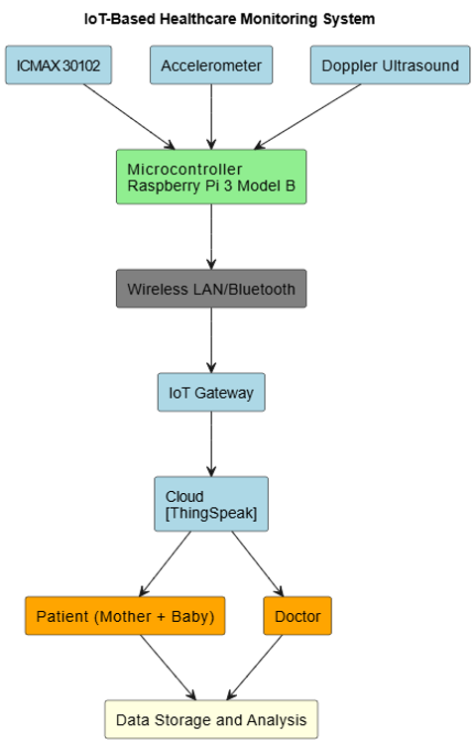

**Fig 4.1: Block Diagram**

## Architecture diagram of the system:

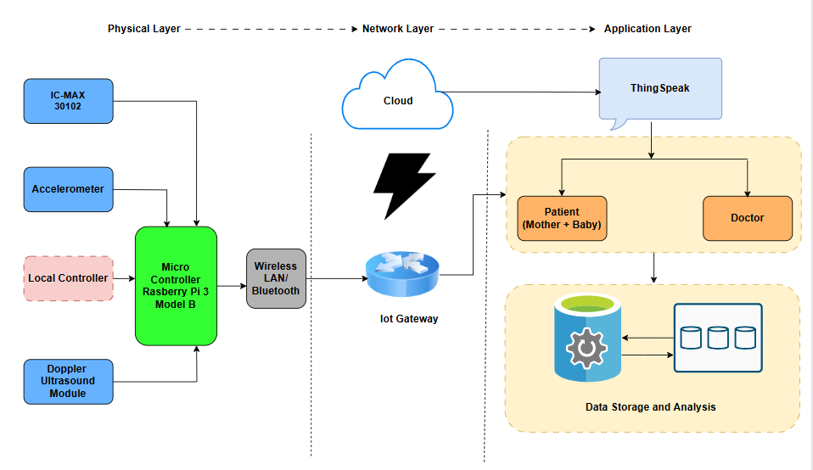

**Fig 4.2: Architecture Diagram**

The provided diagram represents a three-layer architecture (Physical Layer, Network Layer, and Application Layer) for a maternal and fetal health monitoring system. Here’s a breakdown of each layer and its components:

**1. Physical Layer (Hardware Components)**

* + - This layer consists of sensor devices and microcontrollers that collect real-time health data:
    - A pulse oximeter and heart rate sensor used for measuring heart rate and oxygen saturation.
    - Detects fetal movements and maternal body posture changes.
    - Doppler Ultrasound Module: Measures fetal heart rate and blood flow.
    - Local Controller: Manages data from sensors before transmitting it to the microcontroller.

**2. Network Layer (Communication & IoT Gateway)**

* + - This layer ensures data transmission and connectivity:
    - Enables communication between the Raspberry Pi and the IoT gateway.
    - A bridge between the microcontroller and the cloud, handling data transfer securely.
    - Stores the collected data for further processing and remote access.

**3. Application Layer (User Interaction & Analysis)**

* + - This layer processes, analyzes, and presents the collected data:
    - A cloud-based IoT platform where the real-time data is stored and visualized.
    - The monitored individual whose health parameters are being tracked.

## Detailed Design

The block diagram illustrates the architecture of the maternal and fetal health monitoring system, highlighting the interaction between the sensors, processing unit, and user interface. The ADXL345 accelerometer and MAX30102 heart rate sensor are connected to the Raspberry Pi, which acts as the central processing unit for collecting, processing, and transmitting data. Simultaneously, the Doppler Sensor captures fetal heartbeat signals and displays them through a dedicated Fetal Doppler Display unit. Both the Raspberry Pi and Doppler display transmit real-time data to the Web Interface, enabling users and healthcare professionals to monitor fetal movements and heart rate remotely with ease and accuracy.

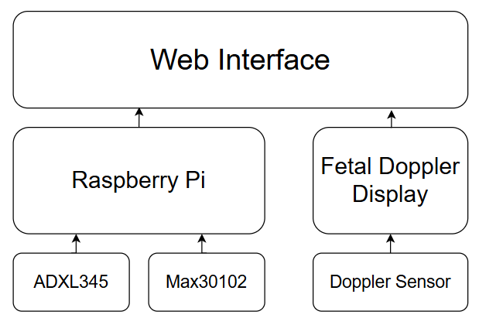

**Fig 4.3 : System Flowchart**

### The hardware design of the maternal and fetal health monitoring system is centered around the Raspberry Pi 3 Model B, which acts as the main controller and data processor. It connects to two essential sensors: the MAX30102 for heart rate monitoring and the ADXL345 accelerometer for fetal movement detection. The sensors communicate with the Raspberry Pi via the I²C protocol, allowing multiple devices to share the same communication lines, thereby simplifying the overall wiring architecture.

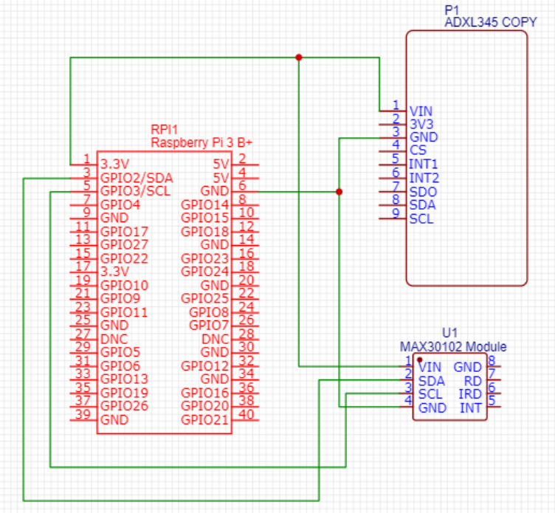

**Fig 4.4 :Connection Details and Pin Diagram**

In the circuit diagram, the MAX30102 sensor module is connected to the Raspberry Pi as follows:

* VIN of the sensor is connected to the 3.3V power supply (Pin 1 on the Pi).
* GND is connected to the ground (Pin 6).
* SDA is wired to GPIO2/SDA (Pin 3) on the Raspberry Pi, which is the I²C data line.
* SCL is connected to GPIO3/SCL (Pin 5), the I²C clock line.
* Similarly, the ADXL345 accelerometer module is connected using the same I²C interface lines:
* VIN is supplied with 3.3V.
* GND goes to the Raspberry Pi’s ground.
* SDA and SCL are connected in parallel to the MAX30102's respective pins, enabling both sensors to communicate with the Pi on the same I²C bus.
* Unused pins such as INT1, INT2, CS, and SDO are either unconnected or reserved for future extensions.

**4.3 Project Scheduling & Tracking using Time line / Gantt Chart:** The Gantt chart of our project where we worked for the whole semester to create this model is shown in a timeline pattern. It is the most important part to think and design the planning of your topic and so we planned our work like the gantt chart shown.

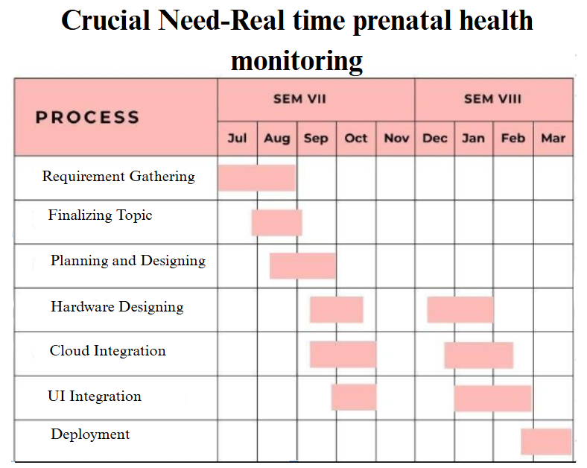

**Fig 4.5 : Gantt chart**

# Chapter 5: Implementation of the Proposed System

## Methodology employed for development:

The project adopted a structured and methodical approach to develop a real-time maternal and fetal health monitoring system using sensor-based hardware and a custom-built application. The primary goal was to create a non-invasive, continuous monitoring solution that could be easily used in both urban and rural settings. The development began by identifying the critical health parameters to be monitored—specifically fetal heart rate and fetal movement, which are essential for assessing the well-being of the baby during pregnancy. Based on these requirements, sensors such as the Doppler ultrasound module for detecting fetal heartbeat and an accelerometer for capturing fetal movements were selected and integrated into the system. These sensors were connected to a Raspberry Pi 3 Model B, which acted as the main processing unit to manage sensor inputs and facilitate real-time data collection and transmission.

Following the successful hardware integration, the focus shifted to building a user-friendly application that would allow mothers and healthcare providers to view real-time data in a clear and accessible format. The application provides live visualizations of the sensor data, such as fetal heart rate and movement readings, making it easy to monitor vital signs. To enhance usability and enable long-term tracking, the system was also integrated with the ThingSpeak cloud platform, which securely stores historical data and offers graphical analysis over time. This feature allows healthcare providers to review trends and make informed decisions regarding maternal and fetal health.

Special attention was given to making the device compact, power-efficient, and comfortable for the mother to wear for extended periods. The final system offers a practical and cost-effective solution for real-time health monitoring, particularly suited for deployment in rural or resource-limited areas where access to regular prenatal check-ups might be limited. By combining essential hardware and a simplified application interface, the project successfully delivers a comprehensive tool for improving prenatal care and early detection of potential health concerns. Extensive testing was carried out to ensure the accuracy of the readings, the reliability of data transmission, and the overall user-friendliness of the application.

## Algorithms and Flowcharts for the respective modules developed:

To ensure a structured development approach, each module of the maternal and fetal monitoring system was designed using specific algorithms and corresponding flowcharts. These guided the logical flow of data acquisition, processing, transmission, and display.

**1. Sensor Data Acquisition Module**

**Algorithm:**

* Initialize Raspberry Pi GPIO pins.
* Configure and initialize the ADXL345, MAX30102, and Doppler sensors.
* Continuously collect data from each sensor.
* Preprocess the data (filter noise, validate values).
* Send the data to the processing unit.

**2. Data Processing and Transmission Module**

**Algorithm:**

* Receive raw data from sensors.
* Apply thresholds and validation checks.
* Format the data into structured packets.
* Transmit data to ThingSpeak cloud via Wi-Fi.

**3. Web Interface Display Module**

**Algorithm:**

* Retrieve live and historical data from the ThingSpeak cloud.
* Parse the incoming JSON/XML feed.
* Display data in readable format (charts, graphs, values).
* Refresh display periodically for real-time updates.

## Datasets source and utilisation:

The primary dataset for this project was generated through real-time data acquisition using biomedical sensors integrated into the hardware system. Sensors such as the MAX30102 (for pulse and oxygen levels), ADXL345 (for body posture and motion), and the Doppler ultrasound module (for fetal heart rate monitoring) were interfaced with the Raspberry Pi. These sensors captured continuous physiological signals from test subjects under controlled conditions.

The acquired data was transmitted in real-time to the cloud using ThingSpeak, which served as the central repository for storage and visualization. Each dataset was timestamped and included values such as heart rate, acceleration in different axes, and Doppler signal intensity. This cloud-based data collection enabled easy tracking and analysis of maternal and fetal health trends over time.

The datasets were primarily utilized for:

* Real-time monitoring through the mobile/web application.
* Validation and calibration by comparing sensor readings with medical-grade devices.
* Visualization and analytics for healthcare professionals to observe variations and assess risk.
* Testing and debugging of the system’s sensor accuracy and data transmission modules.

By generating and using live datasets, the system ensured relevance, reliability, and practical utility in real-world maternal healthcare applications.

# Chapter 6: Testing of the Proposed System

## Introduction to Testing :

Testing is a crucial phase in the development of any health monitoring system, especially when it involves real-time data related to maternal and fetal health. It ensures that the system functions reliably, accurately, and safely under various conditions. For this project, testing was conducted to verify the accuracy of sensor readings, the responsiveness of the application interface, and the stability of data transmission between the hardware and cloud. The primary objective was to confirm that the system delivers consistent and precise results in real-time, ensuring that vital parameters like fetal heart rate and movement are correctly monitored and displayed. Both hardware and software components were thoroughly tested to identify and fix any potential issues before deployment. This phase also included user feedback from trial runs to validate the system's usability, comfort, and performance in practical settings.

## Types of tests Considered:

### Pre testing phase

During the pre-testing phase, rigorous validation of individual sensor modules was carried out to ascertain their functional accuracy and consistency. The accelerometer, ICMAX30102, and Doppler ultrasound sensors were tested independently to verify their responsiveness and precision in capturing physiological data. To ensure credibility, the recorded sensor outputs were cross-referenced with benchmark readings obtained from clinically approved or commercially available monitoring devices. This comparative analysis allowed the identification and resolution of any anomalies in calibration or signal fluctuation. Additionally, signal stability and noise interference were observed under various conditions to fine-tune sensor placement and optimize data capture fidelity. This phase played a crucial role in establishing the foundational reliability of the hardware setup before system integration.

### Beta-Testing Phase

The beta-testing phase was primarily centered on evaluating the integrated system’s performance in real-time operational conditions. Special emphasis was placed on validating the seamless transmission of sensor data to the cloud infrastructure, specifically through the ThingSpeak platform. Successful communication between the hardware components and the cloud environment was ensured, with particular attention to data synchronization, latency, and storage integrity. Furthermore, the responsiveness of the user-facing application was observed to determine its ability to accurately reflect live physiological readings. This phase simulated actual user scenarios to identify potential bottlenecks in data flow, interface usability, and long-term operational stability, thereby enabling refinements before full-scale deployment.

* 1. **Various test case scenarios considered:**

|  | Test Cases |
| --- | --- |
| **Case 1:**  **Sensor Functionality Test**: Verified the correct functioning of the accelerometer, Doppler, and ICMAX30102 sensors for consistent readings. |  |
| **Case 2:**  **Data Transmission Validation**: Ensured real-time sensor data was transmitted successfully from Raspberry Pi to the cloud platform. |  |
| **Case 3:**  **Cloud Data Storage Test**: Checked that all transmitted data was stored properly on ThingSpeak and could be accessed when needed. |  |
| **Case 4:**  **Device Connectivity Check**: Ensured Bluetooth and Wi-Fi modules maintained stable connections during continuous monitoring. |  |
| **Case 5:**  **User Interface Usability Test**: Evaluated the app interface for readability, clarity, and ease of use by non-technical users. |  |

* 1. **Inference drawn from the test cases:**

|  | Test Cases |
| --- | --- |
| **Case 1:**  The sensors (Accelerometer, Doppler, ICMAX30102) provided consistent and accurate readings, verifying that the hardware components functioned as expected. |  |
| **Case 2:**  Real-time data transmission from the Raspberry Pi to the ThingSpeak cloud was stable and successful, with no noticeable data loss or delay. |  |
| **Case 3:**  All transmitted data was properly stored in the cloud and could be retrieved accurately, confirming effective data logging for future analysis. |  |
| **Case 4:**  Bluetooth and Wi-Fi modules maintained continuous and stable connections, supporting uninterrupted monitoring sessions. |  |
| **Case 5:**  The application interface was easy to use, with clearly displayed data, ensuring accessibility even for users with minimal technical background. |  |

# Chapter 7: Results and Discussions

## Screenshot of Use Interface(UI) for the system:

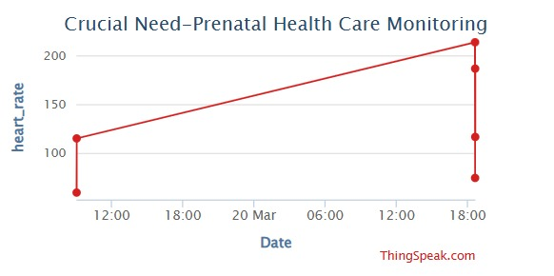

**Fig 7.1: Real-Time Fetal Heart Rate Monitoring Visualization**

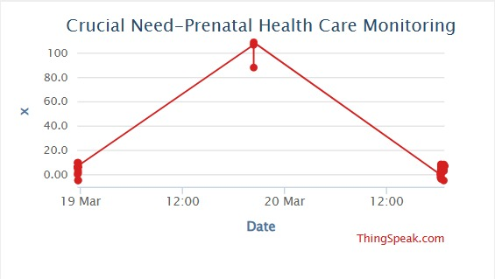

**Fig 7.2: Real-Time Fetal Heart Rate Monitoring Visualization :X-axis**

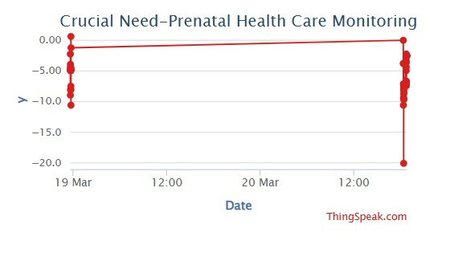

**Fig 7.3: Real-Time Fetal Heart Rate Monitoring Visualization:Y-axis**

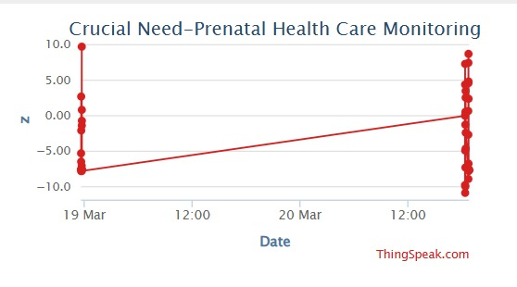

**Fig 7.4: Real-Time Fetal Heart Rate Monitoring Visualization:Z-axis**

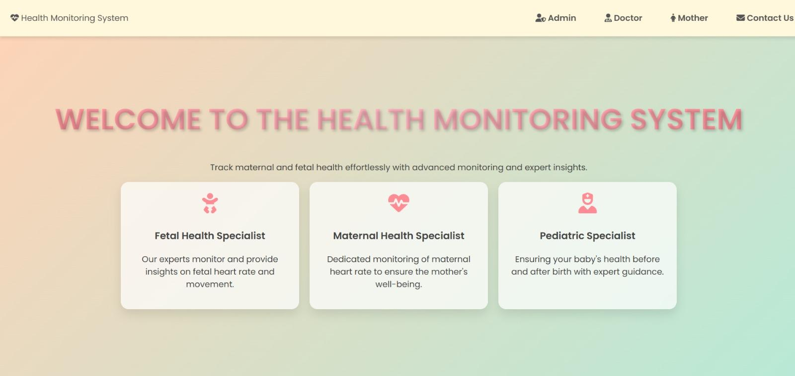

**Fig 7.5: Mother’s Dashboard**

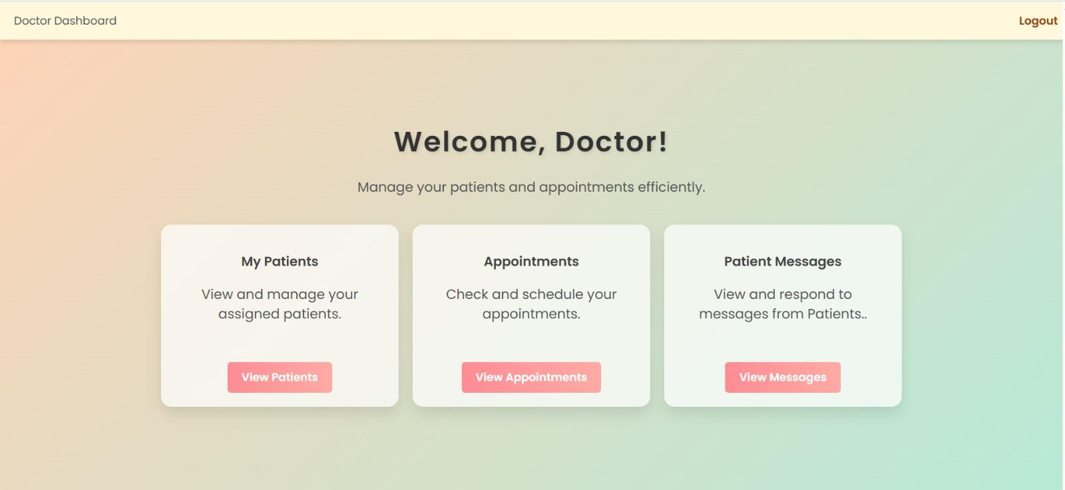

**Fig 7.6: Doctor’s Dashboard**

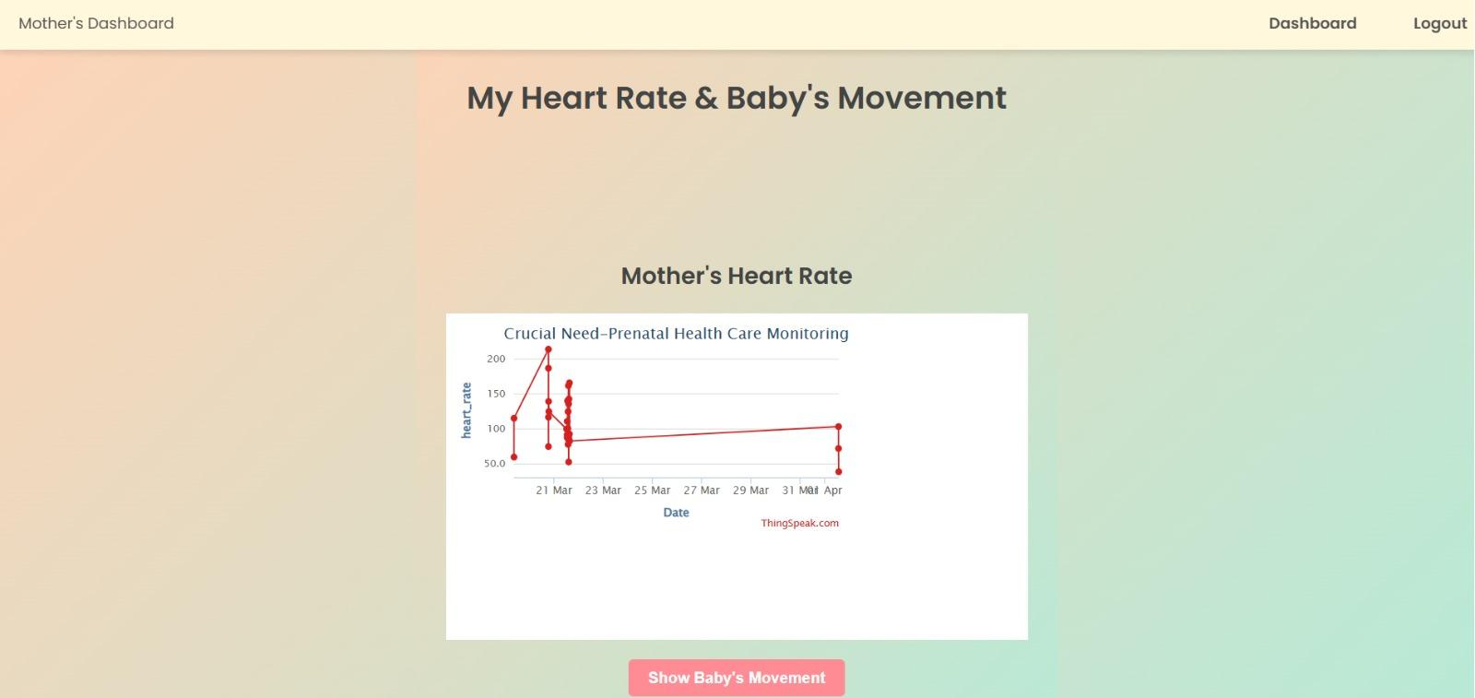

**Fig 7.7: Real-Time Visualization**

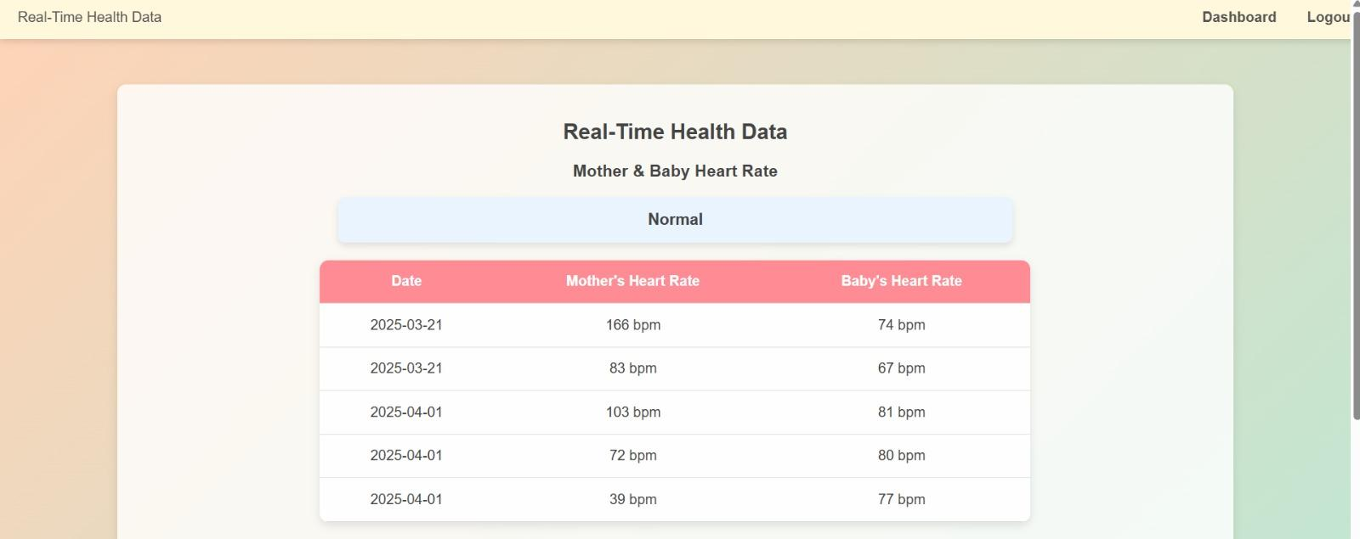

**Fig 7.8: Readings from Sensors**



**Fig 7.9: Chat Support**



**Fig 7.10: Appointments Scheduled**

## Performance Evaluation Measures:

To assess the efficiency and reliability of the proposed maternal and fetal health monitoring system, several performance evaluation measures were implemented:

1. **Sensor Accuracy**:  
    Sensor data from the MAX30102, ADXL345, and Doppler ultrasound modules were compared with readings from clinically approved devices. Accuracy was calculated by evaluating the deviation of sensor output from the reference values.
2. **Data Transmission Reliability**:  
    The reliability of data transmission to the ThingSpeak cloud was measured by tracking data loss, transmission delays, and packet errors during continuous streaming. A near-zero loss rate confirmed robust wireless communication.
3. **System Responsiveness**:  
    The real-time application was evaluated for latency in updating the sensor readings on the interface. The refresh rate and data sync timing were recorded to ensure seamless user experience without lag.
4. **Uptime and Stability**:  
    The overall operational stability of the hardware-software system was monitored over extended periods. High uptime percentages and minimal crash instances indicated a stable and dependable setup.
5. **User Interface Usability**:  
    User interaction metrics were gathered based on test group feedback, focusing on the simplicity of navigation, readability of data, and accessibility for non-technical users, especially in rural environments.
6. **Cloud Integration Efficiency**:  
    The system’s integration with ThingSpeak was assessed in terms of data logging speed, data retrieval success rate, and visual dashboard rendering performance.

These measures collectively ensured that the developed solution meets healthcare-grade monitoring standards with respect to accuracy, usability, and real-time functionality.

## Input Parameters/Features considered:

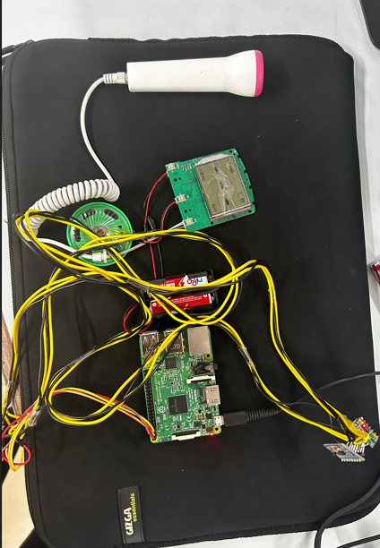 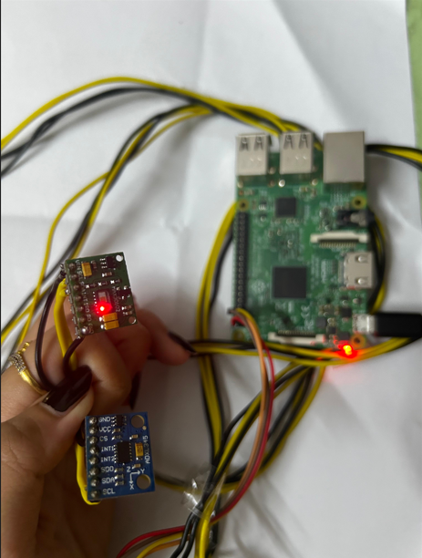

**Fig 7.11: Input from sensors :A Fig 7.12: Input from sensors: B**

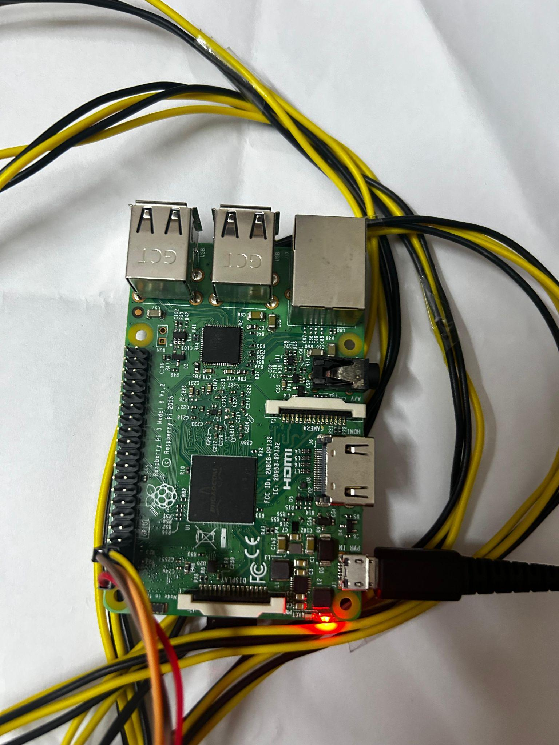

**Fig 7.13: Input from sensors: C**

The system was designed to monitor critical maternal and fetal health indicators by collecting data from multiple sensors. The key input parameters and features considered in the development of the system include:

1. **Fetal Heart Rate (FHR)**:  
    Captured using the Doppler ultrasound sensor, this parameter is crucial for monitoring fetal well-being and detecting any abnormalities in heartbeat patterns.
2. **Maternal Heart Rate (MHR)**:  
    Measured using the MAX30102 pulse oximeter sensor, this feature helps ensure the mother’s cardiovascular health is within safe limits during pregnancy.
3. **Motion and Activity Levels**:  
    The ADXL345 accelerometer was used to capture movement data. This parameter helps assess maternal activity and potential signs of discomfort or risk (e.g., falls, inactivity).
4. **Sensor Timestamping**:  
    Each sensor reading is associated with a timestamp to enable accurate historical tracking and trend analysis through the ThingSpeak cloud platform.
5. **Ambient Noise Interference** (optional):  
    Considered during testing to ensure fetal heartbeat detection remained consistent even in varying environmental conditions.

These parameters were selected based on medical relevance, sensor feasibility, and the ability to offer continuous, real-time insights into maternal and fetal health for early detection and prevention of complications.

## Comparison of Results with Existing System:

| **Other System** | **Our System** |
| --- | --- |
| Many existing systems focus separately on either maternal health or fetal monitoring. | It is an all-in-one package that continuously tracks both maternal and fetal health, ensuring complete prenatal care in a single system. |
| Many systems require high-end infrastructure and frequent hospital visits. | Our system is designed to work efficiently in remote areas with limited medical access. |
| Some systems require professional setup and hospital monitoring. | Our system is easy to use, portable, and suitable for home-based monitoring. |
| Advanced monitoring solutions are often expensive and not widely accessible. | Our system is affordable and scalable, making it suitable for widespread use. |

* 1. **Inference Drawn:**

In existing systems, most systems focus on continuous, non-invasive maternal and fetal health monitoring using wearable sensors, but few integrate real-time remote monitoring with adaptive sensor management for improved efficiency and power conservation. The combination of multiple sensor types, such as Doppler ultrasound, ECG, and accelerometers, for fetal health tracking is a key trend, but the effectiveness of these multi-sensor approaches depends heavily on signal accuracy and noise reduction techniques.

# Chapter 8: Conclusion

## Limitations:

* + - Proper usage and sensor placement depend on user awareness.
    - Data privacy concerns may arise if not handled with secure protocols.
    - Limited clinical validation may restrict acceptance by healthcare institutions.

## Conclusion:

The developed wearable fetal monitoring system enhances prenatal care by providing continuous and non-invasive fetal heart rate tracking. Unlike traditional hospital-based monitoring, which is periodic and may miss transient irregularities, this system enables real-time tracking, offering timely insights for both mothers and healthcare providers.

By integrating sensors such as MAX30102, accelerometers, and Doppler ultrasound, the system ensures accurate detection of fetal heart rate and movements. AI-powered analysis further improves anomaly detection, allowing early identification of potential risks. The data is securely transmitted to the cloud, making it easily accessible through a user-friendly website and mobile application.

This innovation empowers expectant mothers with real-time health information, minimizes the need for frequent hospital visits, and aids doctors in making informed decisions. It has the potential to significantly improve pregnancy outcomes, particularly in high-risk cases, by enabling early intervention. Future enhancements, such as expanding AI-driven diagnostics and incorporating additional maternal health parameters, can further strengthen its role in maternal and fetal healthcare.

## Future Scope:

1. Use advanced AI models for better health risk prediction.
2. Improve mobile app features with alerts and multilingual support.
3. Integrate with hospital systems for real-time medical access.
4. Add sensors to track more maternal health parameters.

# References

1. Roham, Masoud, Enrique Saldivar, Srinivas Raghavan, Mark Zurcher, Jonathan Mack, and Mehran Mehregany. "A mobile wearable wireless fetal heart monitoring system." In 2011 5th International Symposium on Medical Information and Communication Technology, pp. 135-138. IEEE, 2011.
2. Runkle, Jennifer, Maggie Sugg, Danielle Boase, Shelley L. Galvin, and Carol C. Coulson. "Use of wearable sensors for pregnancy health and environmental monitoring: Descriptive findings from the perspective of patients and providers." Digital health 5 (2019): 2055207619828220.
3. Ashfaq, Fariha. "Smart Health Monitoring System for Pregnant Women of Rural Regions." Journal of Computers and Intelligent Systems 1, no. 1 (2023).
4. Zhao, Xin, Xianyi Zeng, Ludovic Koehl, Guillaume Tartare, and Julien De Jonckheere. "A wearable system for in-home and long-term assessment of fetal movement." IRBM 41, no. 4 (2020): 205-211.
5. Sotiriadis, A., E. Hernandez‐Andrade, F. da Silva Costa, T. Ghi, P. Glanc, A. Khalil, W. P. Martins et al. "ISUOG Practice Guidelines: role of ultrasound in screening for and follow‐up of pre‐eclampsia." Ultrasound in obstetrics & gynecology 53, no. 1 (2019): 7-22.
6. Marin, Iuliana, Nicolae Goga, Andrei Vasilateanu, Alexandru Gradinaru, and Vlad Racovita. "Smart solution for the detection of preeclampsia." In 2019 E-Health and Bioengineering Conference (EHB), pp. 1-4. IEEE, 2019.
7. Yan, Laifa, Shan Ling, Rongsong Mao, Haoran Xi, and Fei Wang. "A deep learning framework for identifying and segmenting three vessels in fetal heart ultrasound images." BioMedical Engineering OnLine 23, no. 1 (2024): 39.
8. Vo, Khuong, Tai Le, Amir M. Rahmani, Nikil Dutt, and Hung Cao. "An efficient and robust deep learning method with 1-D octave convolution to extract fetal electrocardiogram." Sensors 20, no. 13 (2020): 3757.
9. Kamarozaman, Nurazamiroz Bin, and Aziati Husna Awang. "IOT COVID-19 portable health monitoring system using Raspberry Pi, node-red and ThingSpeak." In 2021 IEEE Symposium on Wireless Technology & Applications (ISWTA), pp. 107-112. IEEE, 2021.
10. Sharma, Anirvin, Tanupriya Choudhury, and Praveen Kumar. "Health monitoring & management using IoT devices in a cloud based framework." In 2018 international conference on advances in computing and communication engineering (ICACCE), pp. 219-224. IEEE, 2018.
11. ShindePatil, Vivek, and M. A. Hopkinton. "Stem Cell Research and Regenerative Medicine." CELL AND: 26.
12. https://pediaa.com/what-is-the-difference-between-bradycardia-and-tachycardia/
13. <https://docs.cirkitdesigner.com/component/2f8c3f07-aed0-0afb-86d1-00474100819a/max30102-heart-rate-and-oxygen-sensor>
14. https://pimylifeup.com/raspberry-pi-accelerometer-adxl345/
15. https://www.mayoclinic.org/doppler-ultrasound/expert-answers/faq-20058452#:~:text=What%20is%20a%20Doppler%20ultrasound,are%20circulating%20in%20the%20bloodstream.
16. https://my.clevelandclinic.org/health/diagnostics/22715-doppler-ultrasound
17. https://medium.com/google-cloud/cloud-iot-step-by-step-connecting-raspberry-pi-python-2f27a2893ab5
18. https://www.cincinnatichildrens.org/health/f/fetal-bradycardia
19. https://www.cincinnatichildrens.org/health/f/fetal-tachycardia

# Appendix

## Paper I details :-

* + 1. **Paper I :-**

**RESEARCH ARTICLE**

**Title: NeoSync: Smart Fetal Health Monitoring with IoT & AI**

Nusrat Ansari1, Vanshika Lalwani2, Madhura Gaval3, Kalpana Gurnani4, Prerna Banswani5

|  | **Abstract:** Monitoring fetal heart rate (FHR) is essential for ensuring the health of both the mother and the fetus during pregnancy. Traditional prenatal check-ups occur at set intervals, which may lead to the overlooking of short-term abnormalities and delay crucial interventions. To address this, a wearable, non-invasive device has been created to enable continuous FHR monitoring. This device is lightweight, ergonomically designed for daily use, and allows expectant mothers to consistently track fetal movements. Utilizing advanced sensors such as an accelerometer, ICMax30102, and Doppler, the device captures real-time heart rate data. The system has demonstrated high accuracy, achieving 96.43% for the accelerometer, 100% for the IC MAX30102, and 94.12% for the Doppler sensor. Data is wirelessly transmitted to a dedicated web platform, allowing both users and healthcare providers to easily access real-time information and trend reports. Early testing shows that the device effectively identifies subtle FHR variations that may not be detected during routine visits. This technology aims to provide continuous monitoring and timely insights, enhancing proactive prenatal care. By giving both mothers and clinicians access to up-to-date information, this system has the potential to improve pregnancy outcomes and boost confidence throughout the pregnancy journey. |
| --- | --- |
| **A R T I C L E H I S T O R Y** |
| Received:  Revised:  Accepted:  *DOI:* |

**Keywords:** Fetal Heart Rate (FHR), Prenatal Monitoring, Wearable Technology, Artificial Intelligence (AI), Real-time Health Monitoring, Maternal Health, Non-invasive Device, Pregnancy Care.

**1. INTRODUCTION**

Fetal heart rate (FHR) monitoring [1] serves as a cornerstone of prenatal care, offering critical insights into the health and development of the fetus throughout the course of pregnancy. Conventionally, medical professionals rely on techniques such as Doppler ultrasound [2,3] and electronic fetal monitoring during scheduled antenatal visits to evaluate fetal well-being. Although these methods are proven to be clinically effective, their inherent limitation lies in their periodic nature. Because monitoring is only performed at specific intervals, there is a risk that short-term or transient abnormalities—such as brief episodes of fetal distress—may go undetected. Such delays in detection can hinder timely medical intervention and may subsequently lead to an increased likelihood of complications during pregnancy and delivery.

This limitation is particularly pronounced in high-risk pregnancies, where the likelihood of complications is elevated and the need for close, continuous surveillance becomes significantly more pressing. In such cases, continuous and accurate fetal monitoring is essential for the early identification of physiological anomalies or signs of distress. However, the requirement for frequent in-clinic assessments can be logistically challenging for expectant mothers, contributing to physical and emotional stress. Additionally, the repeated demand for healthcare personnel and equipment places considerable strain on healthcare systems and resources.

Addressing these challenges requires a novel approach to fetal monitoring [1] that extends beyond the confines of traditional clinical environments. Specifically, there is a growing demand for a non-invasive, real-time, and wearable [2, 3] solution that enables consistent and reliable monitoring of fetal parameters in a home or community setting.

In response to this pressing need, the present study centers on the conceptualization, design, and development of a wearable fetal monitoring device, which is integrated with a suite of advanced biomedical sensors. The proposed system is engineered to support real-time data acquisition using a combination of sensors: the ICMAX30102 [4] sensor for capturing fetal heart rate and oxygen saturation levels, the Doppler ultrasound sensor [2,3] for enhanced fetal cardiac activity monitoring, and the ADXL345 accelerometer [5] for detecting fetal movements. These sensors work in unison to provide a comprehensive overview of fetal health metrics.

Once the physiological data is captured, it is processed locally using onboard computational resources embedded within the wearable device. The processed information is then transmitted wirelessly through secure communication protocols to a dedicated web application interface, which allows for immediate access by healthcare providers and expectant mothers alike. This continuous and accessible monitoring framework aims to ensure that any deviations from normal fetal activity patterns can be detected promptly. Early identification of irregularities supports timely clinical decision-making, reduces the risk of adverse pregnancy outcomes, and provides enhanced peace of mind to mothers by keeping them consistently informed about the well-being of their unborn child.

From a theoretical standpoint, this system is grounded in the principles of biomedical signal processing and remote health monitoring. The use of photoplethysmography (PPG) [6] for heart rate and SpO₂ measurement is based on the Beer-Lambert Law, which relates the absorption of light to the properties of the material through which it passes—critical for determining blood oxygenation levels. Doppler ultrasound [2,3] technology leverages the Doppler effect, wherein frequency shifts in reflected sound waves provide insights into the velocity and movement of cardiac tissues. Additionally, fetal movement detection through accelerometry relies on Newtonian mechanics to interpret three-dimensional motion. By integrating these physiological signal modalities with embedded systems and wireless communication theory, the wearable device offers a multidimensional, real-time approach to fetal monitoring [7]—bridging engineering innovation with obstetric care.

This theoretical foundation ensures that each component of the system operates with scientific precision and consistency, reinforcing the reliability and validity of the monitoring process across varying maternal and fetal conditions. Moreover, the integration of these principles enables the system to handle diverse physiological inputs, filter noise from raw biomedical signals, and extract meaningful health indicators in real-time. By applying well-established algorithms grounded in signal processing and mechanical analysis, the device achieves not only accurate measurement but also robustness in dynamic, real-world settings. This fusion of theory and practical design empowers the wearable system to deliver clinically relevant data continuously, forming a strong basis for remote diagnostics, personalized prenatal care, and scalable deployment in both urban and resource-limited healthcare environments.

The growing body of research highlights the significant potential of wearable technologies in enhancing prenatal care, especially in terms of remote monitoring and early detection of fetal anomalies. Wearable sensors, particularly those utilizing photoplethysmography (PPG) [6], have been explored for their ability to continuously track vital parameters such as heart rate and oxygen saturation, making them invaluable in non-invasive health monitoring for pregnant women [6]. These technologies enable expectant mothers to receive continuous data on their fetal health without the need for frequent clinical visits, which is crucial in rural or underserved areas where access to healthcare may be limited [2]. Moreover, systems designed to track fetal movement and cardiac activity using sensors like accelerometers and Doppler ultrasound offer the opportunity to detect subtle changes in fetal behavior that may indicate distress, thereby allowing for timely medical interventions [1, 4]. By integrating these wearable sensors with advanced algorithms for data analysis, real-time monitoring can be seamlessly achieved, improving both maternal and fetal outcomes and significantly reducing the strain on healthcare resources [3]. The increasing reliance on these technologies presents new avenues for personalized, patient-centric care, empowering healthcare providers and mothers to take proactive steps in managing prenatal health [6].

**2. MATERIALS AND METHODS**

2.1 System Design and Requirement Analysis

The development of the real-time fetal heart monitoring system [1, 4, 7] began with a thorough needs assessment, focusing on gaps in traditional prenatal care. Standard clinical monitoring methods, being periodic in nature, often miss brief but significant changes in fetal heart rate (FHR) [1], potentially delaying crucial interventions. To overcome this, a non-invasive, continuous monitoring system was conceptualized, leveraging wearable technology. Key design parameters—such as

accuracy, user comfort, safety, and real-time feedback—were established through consultations with obstetricians and biomedical engineers to ensure medical accuracy, usability, and patient comfort.

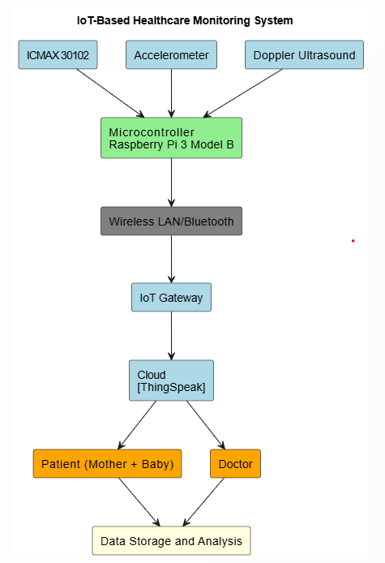

**Fig. (1).** Block diagram of model.

2.2 Selection of Sensors and Hardware Components

The wearable device integrates multiple precision sensors selected for their reliability and non-invasiveness. The key components include:

* MAX30102 Sensor [4]:The MAX30102 is an integrated pulse oximetry and heart-rate monitor sensor based on photoplethysmography (PPG) [26]. It emits red and infrared light into the skin using built-in LEDs and measures the variations in light absorption using a photodetector. These variations correspond to the changes in blood volume during the cardiac cycle, allowing it to detect heart rate and blood oxygen saturation (SpO₂) non-invasively. Its compact size, low power consumption, and I²C interface make it ideal for wearable health monitoring systems, especially for continuous maternal heart rate tracking during pregnancy.
* Doppler Ultrasound [2, 3] Module: Doppler ultrasound modules utilize high-frequency sound waves to detect the movement of blood or fetal heart structures. The module sends ultrasound waves into the body, and when these waves bounce off moving objects (like the fetal heart), their frequency changes slightly—a phenomenon known as the Doppler effect. This frequency shift is analyzed to accurately monitor the fetal heart rate (FHR) and rhythm. Doppler ultrasound is widely used in prenatal care as it provides real-time, non-invasive insights into fetal well-being, making it essential for early detection of abnormalities in fetal circulation and cardiac function.
* ADXL345 (accelerometer) [5]: The ADXL345 is a small, thin, ultra-low power 3-axis accelerometer capable of measuring acceleration in the range. It is highly sensitive to motion and vibration, making it suitable for detecting fetal movement patterns [7] when attached to the maternal abdomen. Fetal kicks or other motions generate subtle vibrations or shifts in position, which are captured by the sensor. Monitoring fetal activity is crucial for assessing the health and development of the fetus, as a reduction in movement can be an early warning sign of distress or developmental issues.

These sensors were chosen to ensure high accuracy in fetal monitoring while maintaining maternal comfort. The Raspberry Pi 3 Model B [5,9] serves as the central processing unit, enabling real-time data handling and AI model deployment with low power consumption.

For wireless data transmission, Bluetooth (for short-range communication) and Wi-Fi (for cloud connectivity) modules were embedded. The device is powered by a high-capacity, power-efficient battery, enclosed in an ergonomically designed case to ensure day-long usability with minimal discomfort.

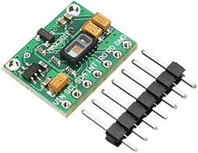

**Fig. (2).** MAX30102

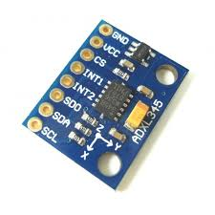

**Fig. (3)**. ADXL345

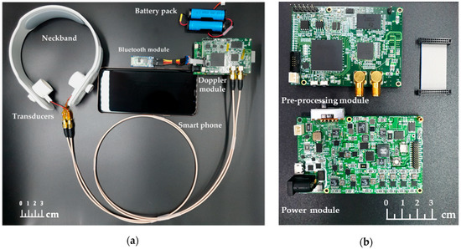 **Fig. (4).**Doppler Ultrasound

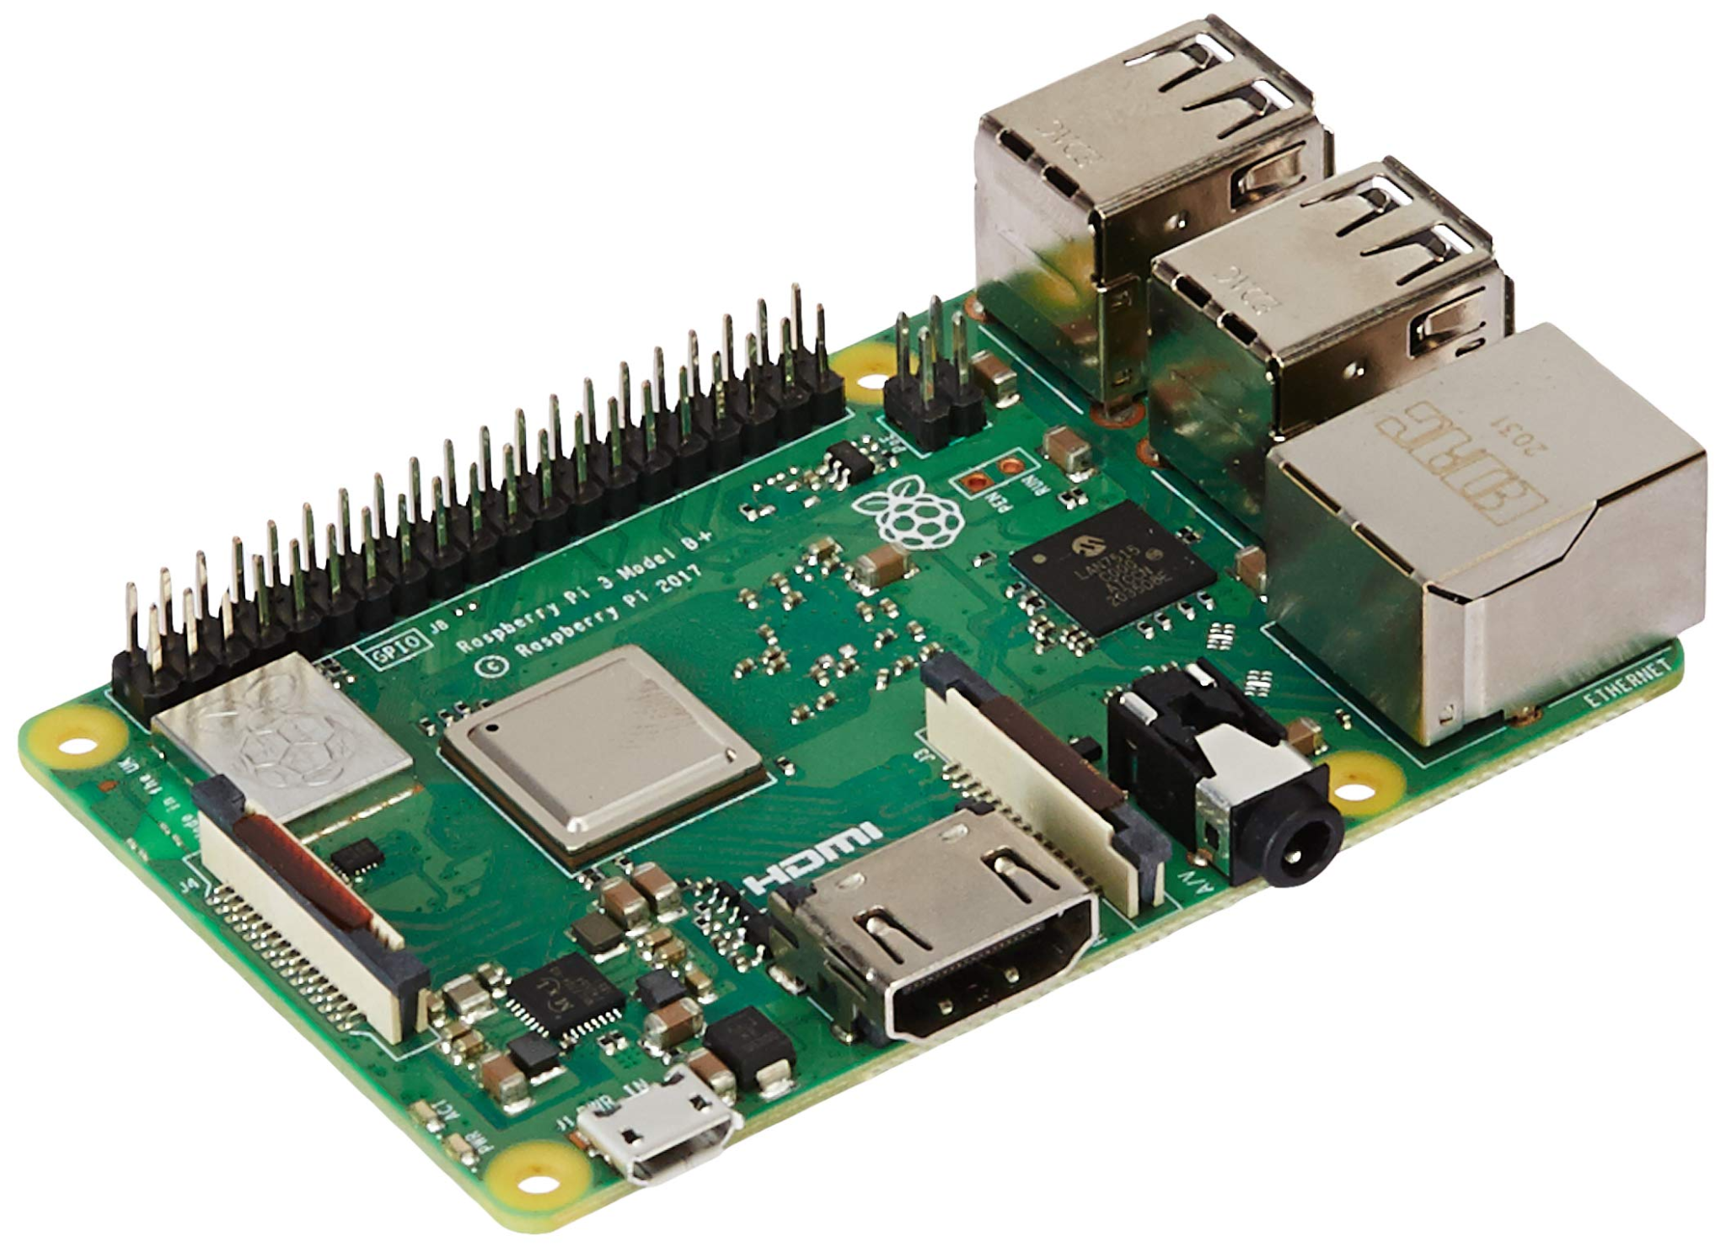

**Fig. (5).** Raspberry Pi 3 Model B

2.3 Data Collection and Signal Processing

Captured signals from the sensors undergo preprocessing to ensure clarity and usability for analysis. The signal processing pipeline includes:

* Noise reduction algorithms to eliminate external interferences.
* Band-pass filters to isolate fetal heart signals from maternal and environmental noise.
* Pattern extraction techniques to identify heartbeat cycles and movement events.

These processed signals are securely stored in a local or cloud-based database and are used for AI-based pattern recognition and anomaly detection.

2.4 AI Model Development and Analysis

The AI model used in this system is based on a Long Short-Term Memory (LSTM) neural network, which is especially effective in handling time-series data. Since fetal movement and heart rate data are continuous and sequential, LSTM helps in learning temporal patterns and detecting any abnormalities in real-time. This model is deployed locally on a Raspberry Pi, allowing for immediate data processing without relying on external servers, which is crucial for real-time monitoring in clinical or home settings.

The input to the LSTM model comes from multiple sensors integrated into the wearable setup. One of the key components is the **Doppler ultrasound sensor**, which measures fetal heart rate using the Doppler effect. This sensor works by emitting ultrasonic waves that bounce off moving structures, such as the fetal heart, and measures the frequency shift to determine the heart rate. It’s a widely used and safe technique for fetal monitoring and provides accurate readings even through maternal tissue. Alongside this, an **accelerometer** captures fetal movements, which is essential in assessing fetal well-being. Additionally, a heart rate sensor, such as the **IC MAX30102**, monitors the mother’s heart rate, helping to distinguish between maternal and fetal signals.

During model evaluation, the LSTM achieved high accuracy, reflecting its effectiveness in correctly identifying fetal states. For example, when trained with data from the accelerometer sensor, it reached an **accuracy of 96.43%,** and with the IC MAX30102 it achieved perfect **accuracy at 100%**. Another classification task showed an accuracy **of 94.12%** for Doppler Ultrasound, with a strong performance in identifying normal conditions (class 0) with 94% precision and 100% recall.

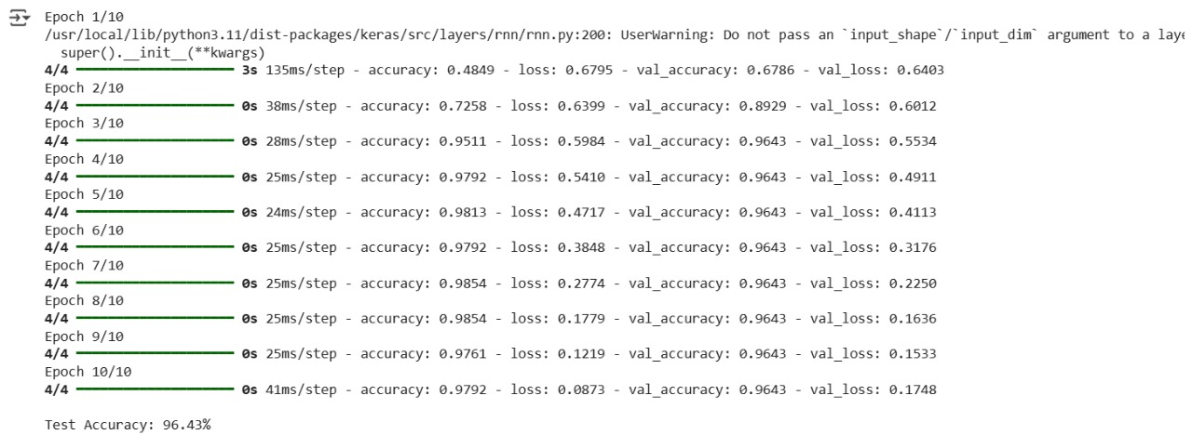

**Fig. (6).** AI Model Accuracy for Accelerometer

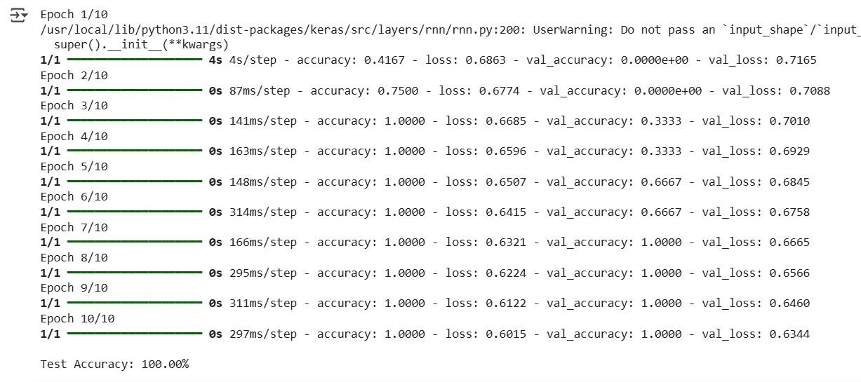

**Fig. (7)**. AI Model Accuracy for ICMAX30102

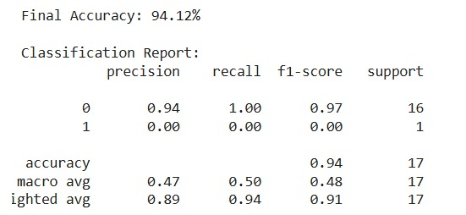

**Fig. (8)**. AI Model Accuracy for Doppler Ultrasound

2.5 Real-Time Monitoring and Alert System

A real-time monitoring framework was developed using edge computing, ensuring that data analysis and alert generation occur without delay or cloud dependency. Features include:

* Instant notifications to the user via web app in case of abnormal readings.
* Healthcare provider alerts for high-risk scenarios.
* Continuous data visualization for users to track fetal well-being trends.
* This closed-loop feedback system ensures that potential complications are addressed promptly.

2.6 User Application and Cloud Integration

The system includes a dedicated web application that offers:

* Live fetal heart rate graphs and historical trends.
* Cloud-based data storage with encryption to maintain data integrity and privacy.
* Remote access for healthcare providers, enhancing prenatal monitoring beyond clinic visits.
* This interface ensures accessibility and supports continuous care for expectant mothers.

2.7 Testing and Validation

To validate system performance, a multi-phase testing protocol was followed:

* Hardware validation compared sensor outputs with standard clinical devices.
* Model validation was conducted using benchmark datasets and real-time signals to assess AI accuracy.
* User testing involved expectant mothers using the device over a trial period to evaluate comfort, usability, and alert responsiveness.
* Expert feedback from gynecologists and technicians was collected to improve design reliability.

2.8 Deployment and Future Enhancements

Following successful testing, the prototype is being prepared for broader deployment. Future enhancements include:

* Integration with maternal health metrics (e.g., blood pressure, temperature).
* Expanded AI capabilities for predictive analytics on labor onset and fetal stress.
* Scalability studies to assess feasibility for mass production and commercial use.

This approach ensures a scalable, medically reliable, and patient-friendly monitoring solution that can significantly enhance prenatal care, particularly in low-resource settings.

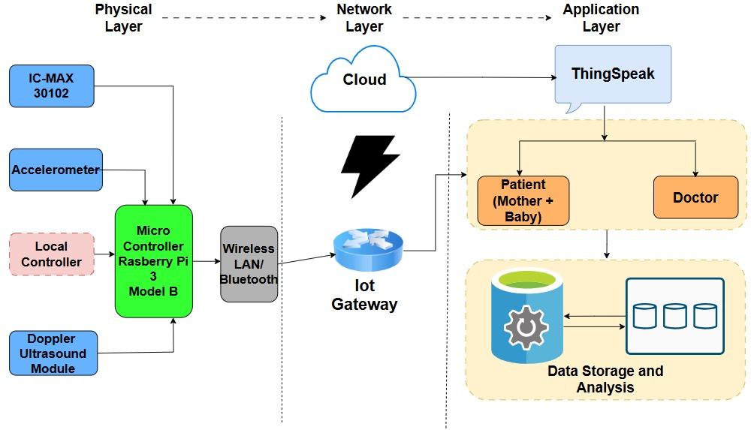

**Fig. (6).** Architecture Diagram

**3. EXPERIMENTAL**

The system's calculations stem from three key sensor technologies integrated into the wearable fetal monitoring device: the MAX30102 pulse oximeter, the ADXL345 accelerometer [5], and a Doppler ultrasound module[2, 3]. Each contributes to precise physiological monitoring based on established scientific principles and validated algorithms.

3.1 Heart Rate and Oxygen Saturation Using MAX30102

The MAX30102 sensor [4] utilizes Photoplethysmography (PPG) [26] to detect variations in blood volume through optical absorption, enabling real-time heart rate and SpO₂ analysis.

* Heart Rate (HR) Calculation is based on detecting peak intervals in the PPG waveform:

BPM= $\frac{Number of peaks in time window}{Time(s)}$ $× 60$ (1)

If in 10 seconds it detects **18 peaks**:

BPM= $\frac{18}{10}$ ×60 = 108 BPM (2)

* Oxygen Saturation (SpO₂) is determined through the differential absorption of red and infrared light:

*R =* (3)

*SpO2  = A - B* x *R* (4)

If A=110, B=13.13 and R=1.02

SpO2=110−13.13×1.02 ≈ 96.655

Here, AC and DC represent the alternating and direct current components of light absorption, and A, B are calibration constants.

* The light absorption model is derived from the Beer-Lambert law

*I*(t) = *I*0*e-*: (5)

where I0 is the incident light intensity, a is the absorption coefficient, and d is the penetration depth.

3.2 Fetal Movement Detection Using ADXL345 Accelerometer

The ADXL345 [14] captures tri-axial movement to infer fetal activity. Movement acceleration is calculated from:

$a_{x}$ = $\frac{V_{x}- {V_{x0}}_{}}{t}$ (6)

$a_{y}$ = $\frac{V_{y}- {V_{y0}}_{}}{t}$ (7)

$a_{z}$ = $\frac{V_{z}- {V_{z0}}_{}}{t}$ (8)

The resultant or total acceleration is:

$a_{total}$ = $\sqrt{a_{x}^{2 }+ a_{y}^{2}+ a_{z}^{2}}$ (9)

Sudden spikes in $a_{total}$ indicate fetal movement, which is logged and analyzed for frequency and regularity.

Let’s compute an example from Response:

* $a_{x}$ =7.34, $a_{y}$ =−7.41, $a_{z}$ =2.39

$a_{total}$ = $\sqrt{{(7.34)}^{2}+ {(-7.41)}^{2}+{(2.39)}^{2}}$ ≈ 10.7

If $a_{total}$ ​ suddenly spikes compared to the previous values (say jumps from 8 to 11), it signals **fetal movement**.

3.3 Fetal Heart Rate via Doppler Ultrasound

The Doppler sensor detects fetal heart rate based on the Doppler Effect:

$f_{d}$*= $\frac{2f_{0}v cos θ}{c}$*  (10)

where:

* fd = Doppler shift frequency
* f0​ = transmitted frequency
* v = velocity of moving heart tissue
* θ = angle between beam and motion direction
* c = speed of sound in human tissue (~1540 m/s)

*H R* = $\frac{Number of detected peaks in Doppler signal}{Time interval}$ $× 60$ (11)

If in 5 seconds it detects **12 peaks**:

BPM= $\frac{12}{5}$ ×60 = 144 BPM (12)

This allows continuous monitoring without invasive methods.

3.4 Software Processing and Real-time Monitoring

Data collected by sensors is pre-processed on Raspberry Pi 3B [5], which filters noise and formats the data. This is followed by secure transmission to ThingSpeak Cloud [9] via HTTP or MQTT protocols.

Real-time data visualization is provided through a web-based dashboard. This platform integrates:

* Graphical displays for HR, SpO₂, and movement,
* Historical trend tracking, and
* Automated alerts based on abnormal thresholds.

ThingSpeak’s RESTful API [9] ensures secure, efficient communication between the device and web platform.

This calculation framework effectively combines hardware sensor theory, signal processing models, and software architecture to create a medically relevant, scalable fetal monitoring system. The use of established physiological formulas, paired with real-time data handling and analysis, supports both immediate response and longitudinal healthcare insights.



**Fig. (7).** Pin Diagram

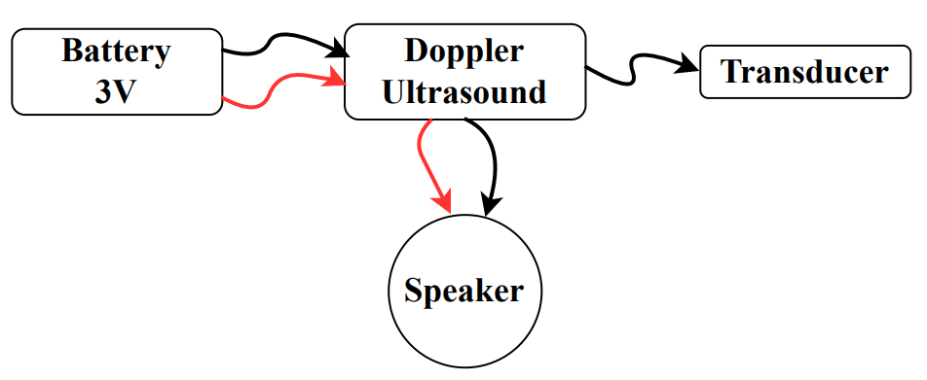

**Fig. (8).** Doppler Ultrasound Working

**4. RESULTS**

**Table 1.** The table outlines the sensors used in the health monitoring system. IC MAX30102 measures heart rate (bpm) and oxygen saturation (%), the ADXL345 (accelerometer) detects baby movement (m/s²), and the Doppler sensor monitors fetal heart rate (bpm). Relevant references [2]–[5] support their applications.

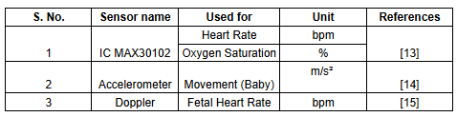.

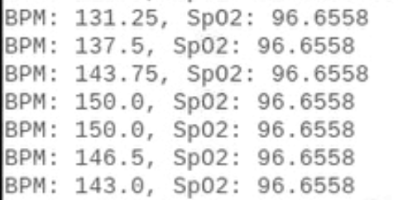

**Fig. (9).** ICMAX 30102 Readings

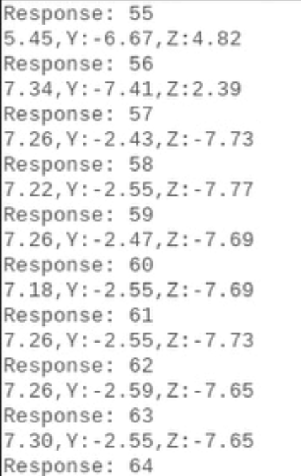

**Fig. (10).** ADXL345 Readings

**Table 2**. IC MAX30102 Sensor Readings (Heart Rate and SpO₂)

| **Blood Per Minute(BPM)** | **Peripheral Capillary Oxygen Saturation**.(SpO2) |
| --- | --- |
| 131.25 | 96.655 |
| 137.5 | 96.6558 |
| 143.75 | 96.655 |
| 150.0 | 96.6558 |
| 150.0 | 96.6558 |
| 146.5 | 96.6558 |
| 143.0 | 96.655 |

**Table 3**. ADXL345 Accelerometer Readings (Baby Movement in m/s²)

| Response | X(m/s²) | Y(m/s²) | Z(m/s²) |
| --- | --- | --- | --- |
| 55 | 5.45 | -6.67 | 4.82 |
| 56 | 7.34 | -7.41 | 2.39 |
| 57 | 7.26 | -2.43 | -7.73 |
| 58 | 7.22 | -2.55 | -7.77 |
| 59 | 7.26 | -2.47 | -7.69 |
| 60 | 7.18 | -2.55 | -7.69 |

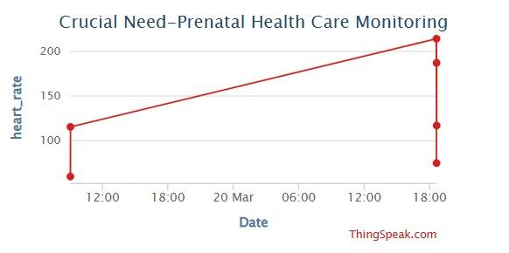

**Fig. (11).** Heart rate data visualization using ThingSpeak [9]

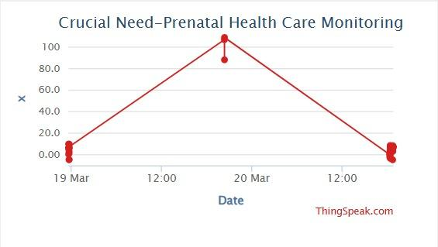

**Fig. (12).** ADXL345 X-axis acceleration readings indicating lateral fetal movement

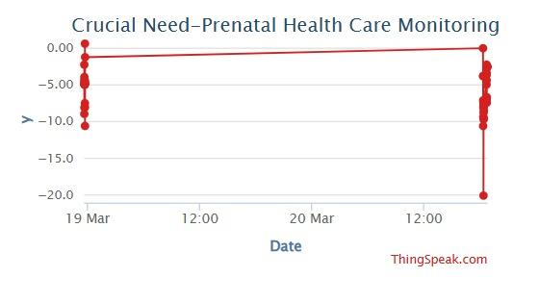

**Fig. (13).**  ADXL345 Y-axis acceleration readings indicating vertical fetal movement

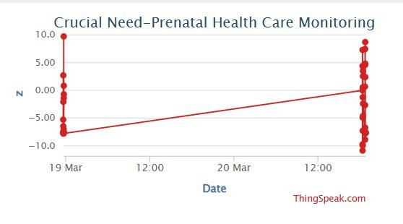

**Fig. (14).** ADXL345 Z-axis acceleration readings indicating depth-wise fetal movement



**Fig. (15).** Homepage of the **Health Monitoring System** web application.



**Fig. (16).** Appointment page in Doctor’s dashboard.



**Fig. (17).** Health records data(heart rate of mother and baby) fetched from thingspeak and shown in Mother’s dashboard.

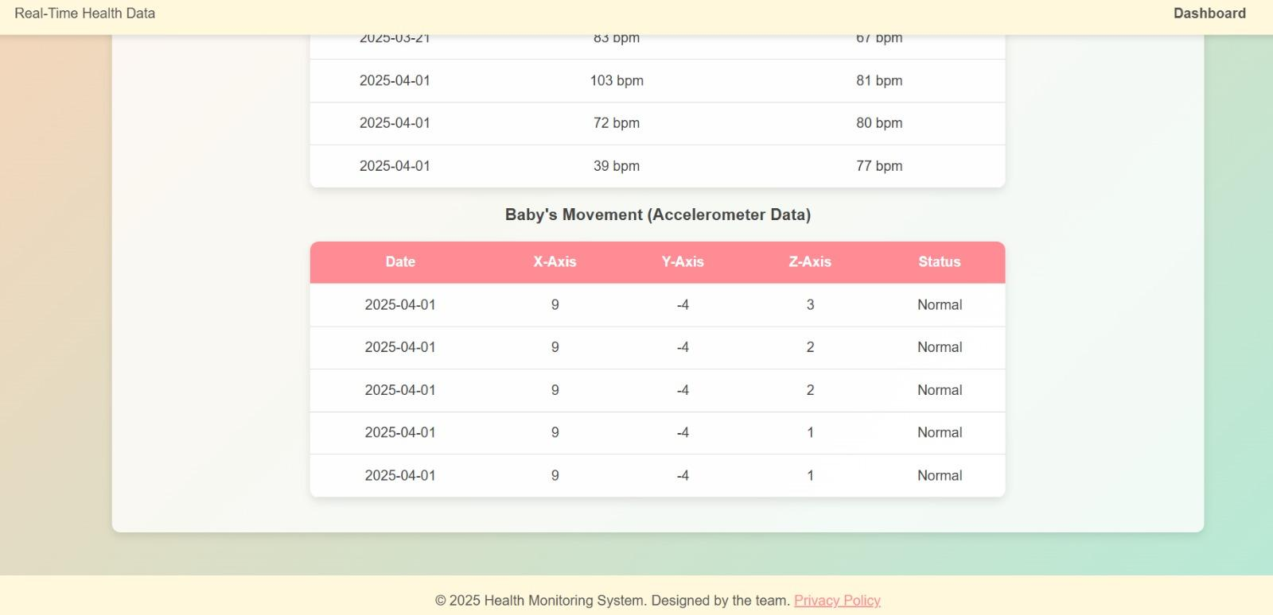

**Fig. (18).** Health records data(ADXL345 (accelerometer) readings) fetched from thingspeak and shown in Mother’s dashboard.

**5. DISCUSSION**

**Table 2.** The table compares existing healthcare monitoring systems with the proposed project. It highlights that while previous systems focus on either fetal movement, heart monitoring, or broader health scopes, the proposed solution integrates both maternal and fetal monitoring using sensors like ADXL345 and MAX30102, along with real-time cloud data access, offering a more comprehensive and advanced approach.

TITLE

| **S. No.** | **Project / Article Name** | **Comparison with our Project** | **References** |
| --- | --- | --- | --- |
| 1. | A Mobile Wearable Wireless Fetal Heart Monitoring System (Roham et al., 2011) | Similar in goal. Our project adds an ADXL345 (accelerometer) along with Doppler and uses ThingSpeak cloud for data analysis.  Accuracy Comparison:  Compared project ~92%;  Ours: 96.43% (Accelerometer), 94.12% (Doppler), 100% (MAX30102) | [9, 2, 3] |
| 2. | Use of Wearable Sensors for Pregnancy Health and Environmental Monitoring (Runkle et al., 2019) | Broader scope including environmental health. Our system is more focused on heart and movement monitoring.  Accuracy Comparison:  Compared project: No specific accuracy on fetal/maternal vitals;  Ours: Up to 100% on heart monitoring | [2, 8, 4] |
| 3. | Smart Health Monitoring System for Pregnant Women of Rural Regions (Ashfaq, 2023) | Shares the rural healthcare objective. Our project provides specific sensor integration and real-time cloud access.  Accuracy Comparison:  Compared project: General health focus, no model accuracy reported;  Ours: 94.12% overall | [10, 18] |
| 4. | A Wearable System for In-home and Long-term Assessment of Fetal Movement (Zhao et al., 2020) | Focuses only on fetal movement. Our system adds maternal data and fetal heart monitoring as well.  Accuracy Comparison:  Compared Project : Movement detection ~90%;  Ours: 96.43% (Accelerometer) | [17, 13, 27, 8, 1] |
| 5. | MAX30102 Heart Rate and Oxygen Sensor Documentation | Hardware documentation for MAX30102. Our project uses this sensor for maternal heart rate detection.  Accuracy Comparison:  Compared Project: Sensor-focused only;  Ours: 100% model accuracy with MAX30102 | [4] |
| 6. | Raspberry Pi ADXL345 (accelerometer) ADXL345 Tutorial | Tutorial for ADXL345 (accelerometer) with Pi. Supports Our system’s movement tracking functionality.  Accuracy Comparison:  Compared Project: No model testing;  Ours: 96.43% using accelerometer data | [5] |

The proposed IoT-based healthcare monitoring system offers a novel, integrated approach to maternal and fetal health monitoring by combining multiple sensors—MAX30102 for maternal heart rate, an accelerometer for fetal movement, and Doppler ultrasound [2,3] for fetal heart detection—connected through a Raspberry Pi and enabled by ThingSpeak cloud storage. In comparison to recent developments in the field, the project stands out due to its real-time data transmission, dual-patient tracking (mother and baby), and accessible communication infrastructure suited for both clinical and remote settings. While earlier studies have individually addressed fetal monitoring, environmental influences, or wearable solutions, this system merges these advancements into a single, scalable, and cost-effective platform. The comparative analysis highlights the significance of the project in addressing rural healthcare challenges, improving early detection of fetal abnormalities, and enhancing the decision-making ability of doctors through timely insights.

**CONCLUSION**

The wearable fetal monitoring system developed in this project represents a significant leap forward in prenatal care, enabling continuous, real-time, and non-invasive tracking of fetal heart rate (FHR). Traditional prenatal check-ups are typically spaced out, which may result in the failure to detect subtle fetal health changes that need immediate attention. This system incorporates advanced sensors, including the ICMax30102 for pulse oximetry, Doppler ultrasound for FHR monitoring, and the ADXL345 accelerometer for motion detection, ensuring precise and real-time data capture. The system has shown excellent accuracy, achieving 100% for the ICMax30102, 96.43% for the accelerometer, and 94.12% for the Doppler sensor. The data collected is processed using AI algorithms, providing real-time insights that help healthcare providers and expectant mothers identify potential anomalies early. The cloud-based platform and easy-to-use interface allow for quick access to health information, reducing the need for frequent clinic visits and giving mothers the ability to track their pregnancy progress at their convenience.

This innovation enables continuous monitoring, improving the chances of detecting any issues early and allowing timely medical intervention, which can significantly enhance pregnancy outcomes. It reduces the need for regular clinical visits while maintaining high-quality care. Future work may involve enhancing the AI’s detection capabilities and expanding the system's functionality. As the technology matures, it holds the potential to offer a more personalized and data-driven approach to prenatal care, contributing to better management of both maternal and fetal health.

With the ability to offer continuous monitoring, this system provides expectant mothers with confidence by ensuring their pregnancy is being monitored closely without the burden of frequent doctor visits. This is especially valuable for high-risk pregnancies, where timely intervention is critical. The system strengthens the connection between healthcare providers and mothers, fostering quicker and more informed decisions. As the system develops, it has the potential to be more widely adopted, offering significant benefits to prenatal care on a global scale, improving maternal and fetal health outcomes.

**LIST OF ABBREVIATIONS**

No abbreviations are used in this paper.

**CONSENT FOR PUBLICATION**

We, the authors, declare that the present work is a part of our academic research undertaken as students under the guidance of our assigned mentor. This project was conducted with full approval from our department.

We confirm that no personal or sensitive data of individuals (including audio-video materials or identifiable information) has been disclosed without appropriate consent. Wherever applicable, necessary approvals and permissions were obtained prior to inclusion. Our mentor has granted us permission to publish this paper based on our work in the field of maternal and fetal health monitoring.

**AVAILABILITY OF DATA AND MATERIALS**

The data supporting the findings of this study were collected in real-time using three sensors: the **MAX30102** [13] (Pulse Oximeter and Heart Rate Sensor), the **ADXL345** (Accelerometer for fetal movement detection) [5], and a **Doppler sensor** [2, 3] (for fetal heart rate monitoring). The sensor data was acquired through direct experimentation and processed using Raspberry Pi 3B [14], with real-time visualization enabled via the ThingSpeak Cloud [9] platform. All data used in this study is original and was obtained through the experimental setup; it is not publicly available but can be provided by the authors upon reasonable request.

**FUNDING**

This research did not receive any specific grant from funding agencies in the public, commercial, or not-for-profit sectors. It was conducted as part of the academic work of the authors and was not financially supported by any employer or organization.

**Conflict of Interest**

The authors declare that there are no financial contributions or funding sources for this study. Therefore, there is no conflict of interest.

**Acknowledgements**

All authors have contributed equally to the conception, design, implementation, analysis, and writing of this study. Each author has reviewed and approved the final version of the manuscript. No other individuals, companies, or institutions have contributed significantly to the intellectual content or drafting of the manuscript.

**REFERENCES**

[1]https://www.hopkinsmedicine.org/health/treatment-tests-and-therapies/fetal-heart-monitoring#:~:text=External%20fetal%20heart%20monitoring,fetal%20heart%20rate%20during%20labor.

[2]https://www.mayoclinic.org/doppler-ultrasound/expert-answers/faq-20058452#:~:text=What%20is%20a%20Doppler%20ultrasound,are%20circulating%20in%20the%20bloodstream.

[3] https://my.clevelandclinic.org/health/diagnostics/22715-doppler-ultrasound

[4]https://docs.cirkitdesigner.com/component/2f8c3f07-aed0-0afb-86d1-00474100819a/max30102-heart-rate-and-oxygen-senso

[5] https://pimylifeup.com/raspberry-pi-ADXL345 (accelerometer)-adxl345/

[6] Castaneda, D., Esparza, A., Ghamari, M., Soltanpur, C., & Nazeran, H. (2018). A review on wearable photoplethysmography sensors and their potential future applications in health care. *International Journal of Biosensors & Bioelectronics, 4*(4), 195–202. <https://doi.org/10.15406/ijbsbe.2018.04.00125>

[7] Zhao, Xin, et al. "A wearable system for in-home and long-term assessment of fetal movement." IRBM 41.4 (2020): 205-211.​

[8] Vo, Khuong, Tai Le, Amir M. Rahmani, Nikil Dutt, and Hung Cao. "An efficient and robust deep learning method with 1-D octave convolution to extract fetal electrocardiogram." Sensors 20, no. 13 (2020): 3757.

[9] Kamarozaman, Nurazamiroz Bin, and Aziati Husna Awang. "IOT COVID-19 portable health monitoring system using Raspberry Pi, node-red and ThingSpeak." In 2021 IEEE Symposium on Wireless Technology & Applications (ISWTA), pp. 107-112. IEEE, 2021.

[10] Sharma, Anirvin, Tanupriya Choudhury, and Praveen Kumar. "Health monitoring & management using IoT devices in a cloud based framework." In 2018 international conference on advances in computing and communication engineering (ICACCE), pp. 219-224. IEEE, 2018.

[11] ShindePatil, Vivek, and M. A. Hopkinton. "Stem Cell Research and Regenerative Medicine." CELL AND: 26.

[12]https://pediaa.com/what-is-the-difference-between-bradycardia-and-tachycardia/

[13]Zhao, Xin, Xianyi Zeng, Ludovic Koehl, Guillaume Tartare, and Julien De Jonckheere. "A wearable system for in-home and long-term assessment of fetal movement." IRBM 41, no. 4 (2020): 205-211.

[14]Sotiriadis, A., E. Hernandez‐Andrade, F. da Silva Costa, T. Ghi, P. Glanc, A. Khalil, W. P. Martins et al. "ISUOG Practice Guidelines: role of ultrasound in screening for and follow‐up of pre‐eclampsia." Ultrasound in obstetrics & gynecology 53, no. 1 (2019): 7-22.

[15]Runkle, Jennifer, Maggie Sugg, Danielle Boase, Shelley L. Galvin, and Carol C. Coulson. "Use of wearable sensors for pregnancy health and environmental monitoring: Descriptive findings from the perspective of patients and providers." Digital health 5 (2019): 2055207619828220.

[16]Ashfaq, Fariha. "Smart Health Monitoring System for Pregnant Women of Rural Regions." Journal of Computers and Intelligent Systems 1, no. 1 (2023).

[17]Roham, Masoud, Enrique Saldivar, Srinivas Raghavan, Mark Zurcher, Jonathan Mack, and Mehran Mehregany. "A mobile wearable wireless fetal heart monitoring system." In 2011 5th International Symposium on Medical Information and Communication Technology, pp. 135-138. IEEE, 2011.

[18]https://medium.com/google-cloud/cloud-iot-step-by-step-connecting-raspberry-pi-python-2f27a2893ab5

[19]https://www.cincinnatichildrens.org/health/f/fetal-bradycardia

[20]<https://www.cincinnatichildrens.org/health/f/fetal-tachycardia>

[21]Maani, Fadillah, et al. "FetalCLIP: A Visual-Language Foundation Model for Fetal Ultrasound Image Analysis." arXiv preprint arXiv:2502.14807

[22]Qazi, Mohammad Areeb, et al. "Multi-Task Learning Approach for Unified Biometric Estimation from Fetal Ultrasound Anomaly Scans." arXiv preprint arXiv:2311.09607 (2023).

[23]Chen, Chaoyu, et al. "FetusMapV2: Enhanced Fetal Pose Estimation in 3D Ultrasound." arXiv preprint arXiv:2310.19293

[24]"Remote Pregnancy Monitoring." Time, October 30, 2024.

[25]"Many Pregnant Women Live Too Far From a Doctor to Get Regular Care. Here's How Technology Can Help." Time, November 26, 2019

[26]Marin, Iuliana, Nicolae Goga, Andrei Vasilateanu, Alexandru Gradinaru, and Vlad Racovita. "Smart solution for the detection of preeclampsia." In 2019 E-Health and Bioengineering Conference (EHB), pp. 1-4. IEEE, 2019.

[27]Yan, Laifa, Shan Ling, Rongsong Mao, Haoran Xi, and Fei Wang. "A deep learning framework for identifying and segmenting three vessels in fetal heart ultrasound images." BioMedical Engineering OnLine 23, no. 1 (2024): 39.

[28]Vo, Khuong, et al. "An efficient and robust deep learning method with 1-D octave convolution to extract fetal electrocardiogram." Sensors 20.13 (2020): 3757

[29]Yan, Laifa, et al. "A deep learning framework for identifying and segmenting three vessels in fetal heart ultrasound images." BioMedical Engineering OnLine 23.1

[30]Płotka, Szymon, et al. "FetalNet: Multi-task Deep Learning Framework for Fetal Ultrasound Biometric Measurements." arXiv preprint arXiv:2107.06943 (2021)

[31]Fan, X., Zhang, Y., Liu, H., & Zhang, Y. (2023). Smart wearable devices for maternal health monitoring: Current status and future directions. *IEEE Access*, 11, 78439–78452.

[32]Wang, Y., Zhou, M., & Zhang, Y. (2024). AI-enabled wearables for monitoring pregnancy and fetal wellbeing. *Journal of Healthcare Engineering*, 2024, Article ID 8051701.

[33]Raj, A., Jain, S., & Gupta, N. (2022). Design and implementation of real-time fetal monitoring system using wearable sensors and mobile interface. *Biomedical Signal Processing and Control*, 74, 103511.

[34]Dissanayake, D. M., & Fernando, T. (2023). A survey on generative AI models in healthcare: Opportunities and challenges. *Computers in Biology and Medicine*, 164, 107435.

[35]Ahamed, S. I., Hasan, M., & Shaji, R. (2023). IoT and deep learning-based smart belt for fetal health monitoring. *IEEE Sensors Letters*, 7(4), 1–4.

[36]Sharma, P., & Kumar, R. (2024). Privacy-preserving AI for prenatal healthcare systems using federated learning. *Journal of Biomedical Informatics*, 144, 104422.

[37]Rehman, A., et al. (2024). Wearable AI system for continuous monitoring of preeclampsia indicators in pregnant women. *Sensors*, 24(2), 588.

[38]Ghosh, S., & Chakraborty, C. (2023). Real-time monitoring and prediction of fetal health using hybrid CNN-LSTM model. *Neural Computing and Applications*, 35, 9789–9802.

[39]Roy, K., & Bandyopadhyay, S. (2022). Development of a mobile health platform for remote maternal-fetal monitoring using edge AI. *IEEE Journal of Biomedical and Health Informatics*, 26(9), 4318–4327.

[40]Islam, M. M., et al. (2023). A deep generative framework for personalized pregnancy risk prediction. *Artificial Intelligence in Medicine*, 141, 102

* + 1. **Plagiarism Report**



* + 1. **Project Review sheet ; Project review sheet 1:**



**d.Project Review sheet 2**

